Name

Mathematics Stage 5 Paths
Polynomials

Book 1 |  | Version: 261007  Feedback:  https://MrDingMaths.com
Contents
Syllabus Content 2
Learning Intention 3

Syllabus Content
MA5-POL-P-01 defines, operates with and graphs polynomials and applies the factor and remainder theorems to solve problems
Define and operate with polynomials
- Recognise a polynomial expression $a_{n}x^{n}+a_{n - 1}x^{n - 1}+…+a_{2}x^{2}+a_{1}x+a_{0}$ where $n=0, 1, 2…$ and $a_{0}, a_{1}, a_{2},…,a_{n}$ are real numbers
- Describe polynomials using terms such as degree, leading term, coefficient and leading coefficient, constant term, monic and non-monic
- Define a monic polynomial as having a leading coefficient of one
- Apply the notation $P(x)$ for polynomials and $P(c)$ to indicate the value of $P(x)$ for $x=c$
- Add, subtract and multiply polynomials
Divide polynomials
- Identify the dividend, divisor, quotient and remainder in numerical division
- Divide a polynomial by a linear polynomial to find the quotient and remainder
- Express a polynomial in the form $P\left(x\right)=D(x)Q\left(x\right)+R(x)$, where $D(x)$ is the divisor, $Q(x)$ is the quotient and $R\left(x\right)$ is the remainder
Apply the factor and remainder theorems to solve problems
- Verify the remainder theorem and use it to find factors of polynomials and solve related problems
- Develop and apply the factor theorem to factorise particular polynomials completely and solve related problems
- Apply the factor theorem and division to find the zeroes of a polynomial $P(x)$ and solve $P\left(x\right)=0$ (degree$≤4$)
- State the maximum number of zeroes a polynomial of degree $n$ can have
Graph polynomials
- Graph polynomials in factored form
- Graph quadratic, cubic and quartic polynomials by factorising and finding the zeroes
- Relate the term zeroes to polynomial functions and roots to polynomial equations
- Use graphing applications to determine the effect of single, double and triple roots of a polynomial equation $P\left(x\right)=0$ on the shape of the graph for $y=P\left(x\right)$
- Graph polynomials using the sign of the leading term and the multiplicity of roots for the equation $P\left(x\right)=0$
- Use graphing applications to compare the graphs of $y=-P\left(x\right)$, $y=P\left(-x\right)$, $y=P\left(x\right)+c$ and $y=kP\left(x\right)$ to the graph of $y=P\left(x\right)$

Introduction to Polynomials

- Polynomials
- Polynomials are algebraic expressions with many terms and positive powers.
  - Binomial: $2x+3$
  - Trinomial: $3x^{2}+5x+12$
  - Polynomial: $7x^{12}-5x^{9}+3x^{3}+5x-1$

- Polynomials are named by the highest power of $x$.
This is called the degree of the polynomial.
  - Constant: $2$
  - Linear: $3x-7$
  - Quadratic: $2x^{2}-4x+11$
  - Cubic: $-4x^{3}+6x^{2}-x+3$
  - Quartic: $x^{4}-x^{3}-x^{2}-2$
  - Degree 8: $3x^{8}-4x^{5}-3$

- Identify polynomials
✖  $$x^{\frac{1}{5}}$$ | ✔  $$x^{5}$$ |  | ✔  $$-x^{13}+3x^{6}-0.7$$ | ✔  $$2$$ |  | ✖  $$\frac{2}{x}$$
Determine whether the following are polynomials.
- $-x^{2}+5x-4$ |  | - $x^{3}+x^{2}+\sqrt{x}+3$ |  |  | - $7x^{5}+2x^{4}-2$
- $2x^{2}-\sqrt{x}+13$ |  | - $x^{3}+\frac{2}{x}+5$ |  |  | - $\frac{1}{5}x^{3}+3x+13$
- $x^{\frac{1}{3}}-5x^{2}-51x-2$ |  | - $3$ |  |  | - $2-x^{255}$

- Formal Definition of a Polynomial
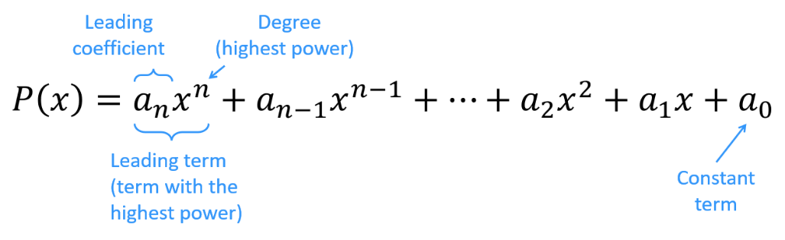
- A polynomial is a function of the form:

The powers are positive whole numbers, including 0.
The coefficients $a_{0},a_{1},a_{2}…$ are real numbers.
- A monic polynomial has leading coefficient of 1.

- Example Describe polynomials
$$P\left(x\right)=x^{3}-3x^{2}-x+2$$  Degree: 3  Leading term: $x^{3}$  Leading coefficient: $1$  Monic/Non-Monic: Monic  Constant term: 2 | $$P\left(x\right)=5x^{2}+2x^{6}-1$$  Degree: 6  Leading term: $2x^{6}$  Leading coefficient: $2$  Monic/Non-Monic: Non-monic  Constant term: $-1$

- Guided Practice
Identify the features of these polynomial functions.
- $P\left(x\right)=3x^{4}-x^{2}+5x-1$  Degree:  4  Leading term:  $$3x^{4}$$  Leading coefficient:  3  Monic/Non-Monic:  non-monic  Constant term:  $$-1$$ | - $P\left(x\right)=4-x+$ $\frac{3x^{2}}{2}$  Degree:  2  Leading term:  $$\frac{{3x}^{2}}{2}$$  Leading coefficient:  $$\frac{3}{2}$$  Monic/Non-Monic:  non-monic  Constant term:  $$4$$

Foundation
- A polynomial expression is given by $3x^{4}-2x^{3}+x^{2}-x+2$.
  - How many terms does the polynomial have?
5
  - State the coefficient of:
$x^{4}$  3 | $x^{3}$  $$-2$$ | $x^{2}$  1 | $$x$$  $$-1$$
  - What is the constant term?
2
- Determine if these polynomials are constant, linear, quadratic, cubic or quartic.
- $2x-5$  linear | - $x^{2}-3$  quadratic | - $x^{4}+2x^{3}+1$  quartic | - $1+x+3x^{2}$  quadratic
- $6$  constant | - $3-\frac{2}{5}x$  linear | - $-2$  constant | - $1-x^{4}$  quartic

- State the leading coefficient in each of the following:
- $2x^{3}+4x^{2}-2x$  2 | - $5x^{4}+3x^{2}-1$  5 | - $2x^{2}-x^{4}-2$  $$-1$$ | - $-7x^{5}+\frac{x^{2}}{2}+8$  $$-7$$

- Identify the degree of each polynomial.
- $5x^{7}-3x^{5}+2x^{3}$  7 | - $3+x+x^{2}-x^{3}$  3 | - $3x+5$  1
- $x^{11}-5x^{8}+4$  11 | - $2-x-5x^{2}+3x^{3}$  3 | - $3$  0

- In each case, state if the function is a polynomial, If so, write down its leading coefficient.
- $f\left(x\right)=2x+3$  Yes, 2 | - $f\left(x\right)={-x}^{3}-4x^{2}+5$  Yes, $-1$ | - $f\left(x\right)=3x^{2}-x^{-1}$  No
- $f\left(x\right)=\sqrt{x}+x-1$  No | - $f\left(x\right)=-\frac{x^{3}}{6}-x+1$  Yes, $-$ $\frac{1}{6}$ | - $f\left(x\right)=\sqrt{x^{2}-9}+1$  No

Development
- Identify the features of these polynomial functions.
- $P\left(x\right)=4x^{3}-2x^{2}-1$  Degree:  3  Leading term:  $$4x^{3}$$  Leading coefficient:  4  Monic/Non-Monic:  Non-monic  Constant term:  $$-1$$ | - $P\left(x\right)=4-\frac{5x^{2}}{2}$  Degree:  2  Leading term:  $$-\frac{5x^{2}}{2}$$  Leading coefficient:  $$-\frac{5}{2}$$  Monic/Non-Monic:  Non-monic  Constant term:  4
- $P\left(x\right)=10-4x-6x^{3}$  Degree:  3  Leading term:  $$-6x^{3}$$  Leading coefficient:  $$-6$$  Monic/Non-Monic:  Non-monic  Constant term:  $$10$$ | - $P\left(x\right)=x^{2}\left(x-2\right)$  Degree:  3  Leading term:  $$x^{3}$$  Leading coefficient:  $$1$$  Monic/Non-Monic:  Monic  Constant term:  0

- A polynomial is a function $P\left(x\right)=x^{3}-7x^{2}+x-1$.
Therefore, we can evaluate polynomials using function notation. Evaluate the following:
- $P(2)$  $$-19$$ | - $P(-1)$  $$-10$$ | - $P(0)$  $$-1$$

- $P\left(x\right)=2x^{4}-3x^{3}+5x-4$. Evaluate:
- $P(1)$  $$0$$ | - $P(3)$  $$92$$ | - $P(-1)$  $$-4$$

- Evaluate $P\left(-2\right)$ for
- $P(x)={\left(x+2\right)}^{2}$  $$0$$ | - $P(x)=(x-2)(x+3)(x+1)$  $$4$$ | - $P(x)=x^{2}(x+5)(x-7)$  $$-108$$

Mastery
- $P\left(x\right)=x^{3}-x^{2}, Q\left(x\right)=4-3x$. Evaluate:
- $P\left(1\right)+Q\left(2\right)$  $$-2$$ | - $P(3)+Q(-1)$  $$25$$ | - $P(-2)-Q(-2)$  $$-22$$
- $Q(1)-P(3)$  $$-17$$ | - ${\left(P\left(2\right)\right)}^{2}+{\left(Q\left(1\right)\right)}^{2}$  $$17$$ | - ${\left(P\left(-1\right)\right)}^{3}-{\left(Q\left(-1\right)\right)}^{3}$  $$-351$$

- Identify the leading term of these polynomials.
- $P\left(x\right)=$ $\frac{4-2x^{2}}{4}$  $$-\frac{1}{2}x^{2}$$ | - $P\left(x\right)=$ $\frac{x^{3}+7x^{2}+x-3}{-7}$  $$-\frac{x^{3}}{7}$$ |  | $P\left(x\right)=$ $\frac{x^{3}+4x^{2}}{-8}$  $$-\frac{x^{3}}{8}$$
- $P\left(x\right)=$ ${\left(x+2\right)}^{2}$  $$x^{2}$$ | - $P\left(x\right)=$ $-\left(x+2\right){\left(x+3\right)}^{2}$  $$-x^{3}$$ |  | $P\left(x\right)=$ $2x{\left(x+5\right)}^{2}(7-x)$  $$-2x^{4}$$
- $P\left(x\right)=$ $(x^{2}-3x)(1-x^{3})$  $$-x^{5}$$ |  | - $P\left(x\right)={\left(2x^{3}-3\right)}^{3}$  $$8x^{9}$$
- For the polynomial $P\left(x\right)=\left(a+1\right)x^{3}+\left(b-7\right)x^{2}+c+5$, find $a$, $b$, $c$ given that:
The degree is 2, $P(x)$ is monic, and the constant term is $-1$

$$a+1=0, b-7=1, c+5=-1$$
$$a=-1,b=8,c=-6$$
- These expressions are equivalent. By expanding and comparing coefficients, find the values of the pronumerals.
  - $\left(a-b\right)x^{2}+\left(2a+b\right)x=7x-x^{2}$

$$a=2, b=3$$
  - $a{\left(x-1\right)}^{2}+b\left(x-1\right)+c=x^{2}$

$$a=1,b=2, c=1$$

Operations with Polynomials

- Add and subtract polynomials
- Add and subtract two polynomials by combining like terms.
- Ensure you write brackets, especially when subtracting.

- Example Add and subtract polynomials
For $P\left(x\right)=x^{2}-x+3$ and $Q\left(x\right)=2x^{2}+x-1$
Find $P\left(x\right)+Q(x)$  $=\left(x^{2}-x+3\right)+\left(2x^{2}+x-1\right)$  $=3x^{2}+2$ | Find $P\left(x\right)-Q(x)$  $=\left(x^{2}-x+3\right)-\left(2x^{2}+x-1\right)$  $=x^{2}-x+3-2x^{2}-x+1$  $=-x^{2}-2x+4$

- Guided Practice
For $P\left(x\right)=x^{3}-x^{2}$ and $Q\left(x\right)=4-3x$:
- Find $P\left(x\right)+Q(x)$  $$x^{3}-x^{2}-3x+4$$ | - Find $P\left(x\right)-Q(x)$  $$x^{3}-x^{\#}+3x-4$$
For $P\left(x\right)=x^{2}-3$ and $Q\left(x\right)=x^{3}-x^{2}+x$:
- Find $3P\left(x\right)+Q(x)$  $$x^{3}+2x^{2}+x-9$$ | - Find $P\left(x\right)-2Q(x)$  $$-2x^{3}+3x^{2}+2x-3$$

- Multiply polynomials using the area model
- $(x-4)(x^{2}+4)$   | - $\left(x^{2}+1\right)\left(x^{3}-x+1\right)$  
- $(x+16)(x^{2}+5x+2)$ | - $(x^{2}+x+1)(x^{3}+2x-3)$  

- Multiplying Polynomials
- Like expanding binomials, we multiply every term of one polynomial by every term of the other polynomial.
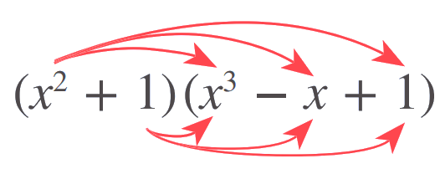

- Example Multiply polynomials
$\left(x^{2}+1\right)\left(x^{3}-x+1\right)$  $=x^{2}\left(x^{3}-x+1\right)+1(x^{3}-x+1)$  $=x^{5}-x^{3}+x^{2}+x^{3}-x+1$  $=x^{5}+x^{2}-x+1$ | $(x^{2}+x+1)(x^{3}+2x-3)$  $=x^{2}\left(x^{3}+2x-3\right)+x\left(x^{3}+2x-3\right)+1(x^{3}+2x-3)$  $=x^{5}+2x^{3}-3x^{2}+x^{4}+2x^{2}-3+x^{3}+2x-3$  $=x^{5}+x^{4}+3x^{3}-x^{2}-6$

- Guided Practice
Expand these expressions.
- $(2x^{2}+1)(3x+4x-3)$  $$14x^{3}-6x^{2}+7x-3$$ | - $(2x-3)(x^{2}-5x+1)$  $$2x^{3}-13x^{2}+17x-3$$
$P(x)=x^{2}+x-1$ and $Q(x)=x^{3}+2x+3$
- Simplify $P\left(x\right)Q(x)$  $$x^{5}+x^{4}+x^{3}+5x^{2}+x-3$$ | - Simplify $P{\left(x\right)}^{2}$  $$x^{4}+2x^{3}-x^{2}-2x+1$$

Foundation
- Find the sum $P\left(x\right)+Q(x)$ and difference $P\left(x\right)-Q(x)$ of these polynomials.
  - $P\left(x\right)=3x^{2}-5x+2$ $Q\left(x\right)=x^{2}+7x-3$
$P\left(x\right)+Q(x)$  $$4x^{2}+2x-1$$ | $P\left(x\right)-Q(x)$  $$2x^{2}-12x+5$$

  - $P\left(x\right)=x^{3}-2x^{2}+3x+7$ $Q\left(x\right)=2x^{3}+3x^{2}-5x+2$
$P\left(x\right)+Q(x)$  $$3x^{3}+x^{2}-2x+9$$ | $P\left(x\right)-Q(x)$  $$-x^{3}-5x^{2}+8x+5$$

  - $P\left(x\right)=x^{4}+9x^{3}+7x^{2}-4x+9$ $Q\left(x\right)=4x^{3}-8x^{2}-15$
$P\left(x\right)+Q(x)$  $$x^{4}+13x^{3}-x^{2}-4x-6$$ | $P\left(x\right)-Q(x)$  $$x^{4}+5x^{3}+15x^{2}-4x+24$$

  - How is the degree of $P(x)±Q(x)$ related to the degree of $P(x)$and $Q(x)$for these polynomials?

the degree of $P(x)±Q(x)P(x)$ is equal to the maximum of the degrees of P(x) and Q(x).
  - Will your answer to part d be true for all polynomials $P(x)$ and $Q(x)$?
(consider what happens if the leading terms of $P(x)$ and$Q(x)$ are opposites.)

No.
For $P\left(x\right)+Q\left(x\right)$, this won’t be the case if both polynomials have the same degree and their leading coefficients sum to zero.
For $P\left(x\right)-Q\left(x\right)$, this won’t be the case if both polynomials have the same degree and their leading coefficients are equal.
- Given $P\left(x\right)=x+5$ and $Q\left(x\right)=2x-1$, find:
- $P(3)$  8 | - $Q(-2)$  $$-5$$ |  | - $P\left(3\right)+Q(-2)$  3
- The degree of $P\left(x\right)+Q(x)$  1 |  | - The degree of $P\left(x\right)Q(x)$  2

Development
- If $P\left(x\right)=5x+2$ and $Q\left(x\right)=x^{2}-3x+1$, find:
- $P\left(x\right)+Q(x)$  $$x^{2}+2x+3$$ | - $Q\left(x\right)+P(x)$  $$x^{2}+2x+3$$ | - $P\left(x\right)-Q(x)$  $$-x^{2}+8x+1$$
- $Q\left(x\right)-P(x)$  $$x^{2}-8x-1$$ | - $P\left(x\right)×Q(x)$  $$5x^{3}-13x^{2}-x+2$$ | - $Q\left(x\right)×P(x)$  $$5x^{3}-13x^{2}-x+2$$

- When multiplying two polynomials, $P(x)$ and $Q(x)$, the degree of the resulting product $P\left(x\right)Q(x)$ will be the sum of the degrees of $P(x)$ and $Q(x)$. Explain why this is true.

The index law of multiplication says we add powers when multiplying the same base.
- Give the degree of the polynomial $P(x)×Q(x)$ when
  - $P(x$) is quadratic and $Q(x)$is linear
3
  - $P(x)$is quadratic and $Q(x)$is cubic
5
  - $P(x)$ is cubic and $Q(x)$ is quartic
7
  - $P(x)$ is of degree 7 and $Q(x)$ is of degree 5
12
- If $P(x) = x^{2}-2x+1$ and $Q(x) = x^{3}+x-1$, what is the degree of:
- $P\left(x\right)×Q(x)$  $$5$$ | - ${\left(P\left(x\right)\right)}^{2}$  $$4$$ | - ${\left(Q\left(x\right)\right)}^{2}$  $$6$$

Mastery
- If $P\left(x\right)=3x-2$ and $Q\left(x\right)=x^{2}-2x+1$, find expressions for:
- $P(x)+Q(x)$  $$x^{2}+x-1$$ | - $P(x)-Q(x)$  $$-x^{2}+5x-3$$ | - $Q\left(x\right)-P\left(x\right)$  $$x^{2}-5x+3$$
- $2Q\left(x\right)-3P\left(x\right)$  $$2x^{2}-13x+8$$ | - $P\left(x\right)Q\left(x\right)$  $$3x^{3}-8x^{2}+7x-2$$ | - $P\left(x\right)Q\left(x\right)+2Q\left(x\right)$  $$3x^{3}-6x^{2}+3x$$

- $P\left(x\right)=ax^{3}+4$. If $P\left(2\right)=28$,
find the value of the leading coefficient $a$ and hence find the polynomial.

$$P\left(x\right)=3x^{3}+4$$
- $P\left(x\right)=ax^{4}+bx^{3}$. If $P\left(1\right)=3$ and $P\left(-2\right)=96$,
use simultaneous equations to find $a$ and $b$ and hence find the polynomial.

$$P\left(x\right)=5x^{4}-2x^{3}$$
- A monomial is an expression with a single term. Complete these divisions, writing the quotient as a sum, or difference, of separate terms.
- $x^{7}÷x^{4}$  $$x^{3}$$ | - $\frac{10x^{10}}{2x^{2}}$  $$5x^{8}$$ | - $\frac{x^{3}}{15}$ $÷$ $\frac{x}{3}$  $$\frac{x^{2}}{5}$$
- $\left(x^{5}+x\right)÷x^{2}$  $$x^{3}+x^{-1}$$ | - $\left(24x^{3}+16x^{2}\right)÷8x^{2}$  $$3x+2$$ | - $\frac{{10x}^{6}-12x^{4}+2x^{2}}{2x^{3}}$  $$5x^{3}-6x+x^{-1}$$
When is the quotient a polynomial?

A quotient is a polynomial when all the terms have non-negative integer powers.
This happens when all terms in the numerator have powers greater than or equal to the power in the denominator.
- Consider $P\left(x\right)=ax^{4}+bx^{3}+cx^{2}+dx+e$.
  - Show that if $P\left(x\right)$ is an even function, then $b=d=0$.

  - Using your result from part a, explain why for an even polynomial, if $x=α$ is a root, then $x=-α$ is also root.

Even polynomial means $P\left(α\right)=P(-α)$.
From part a, every even polynomial only has even powers,
that means if $α$ satisfies the equation $P\left(α\right)=0$, then $P\left(-a\right)$ would also satisfy the equation,
as raising a negative to an even power is the same as raising the positive to an even power.
- Consider $Q\left(x\right)=ax^{5}+bx^{4}+cx^{3}+dx^{2}+ex+f$.
  - Show that if $Q\left(x\right)$ is an odd function, then $b=d=f=0$.

  - Using your result from part a, explain why every odd polynomial must pass through the origin.

From part a, every odd polynomial has terms with odd power.
That means we can factorise $x$ out, hence $x=0$ is a root, i.e. it passes through the origin.

Graphs of Polynomials

- Leading Term and Constant Term

- The leading term determines the end behaviour of the graph.
Leading Term Positive | Leading Term Negative
As $x→∞$, $y→∞$  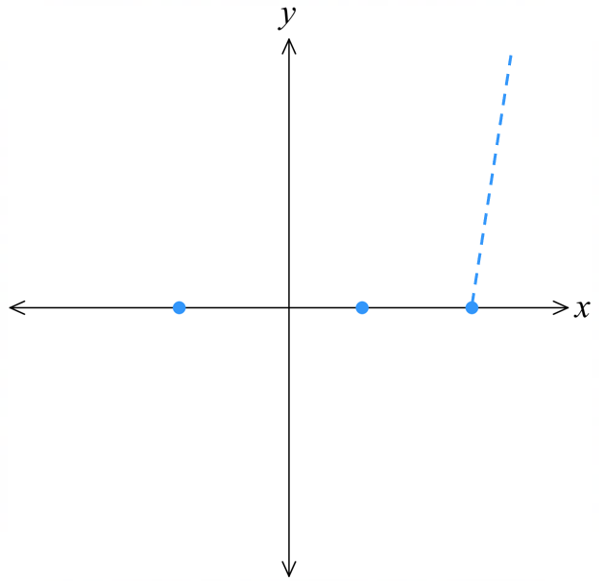 | As $x→∞$, $y→-∞$  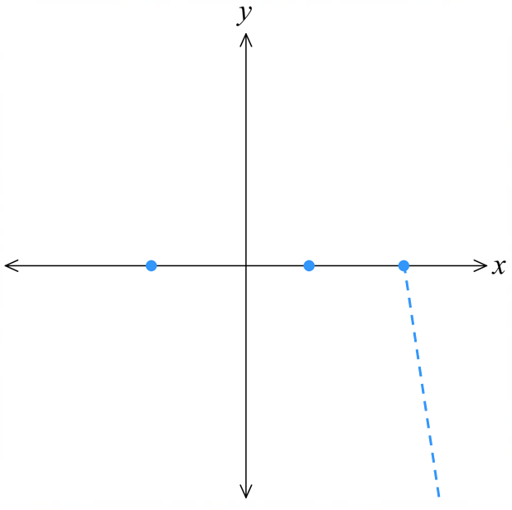
- The behaviour as $x→-∞$ will depend on the degree of the leading term.
- The constant term is the $y$-intercept.

- Identifying Leading Term and Constant Term from a Factored Polynomial
- For a factored polynomial:
  - Find the leading term by multiplying the highest power terms from each factor.
  - Find the constant term by multiplying all constant terms from each factor.

- Identify leading term and constant term from a factored polynomial
- $P\left(x\right)=\left(x-3\right)\left(x-4\right)\left(x+2\right)$  Leading term:  Constant term: | - $P\left(x\right)=\left(2x-3\right)\left(x-4\right)\left(x+2\right)$  Leading term:  Constant term:
- $P\left(x\right)=\left(2x-3\right)\left(4x-4\right)\left(x+2\right)$  Leading term:  Constant term: | - $P\left(x\right)=-\left(2x-3\right)\left(4x-4\right)\left(x+2\right)$  Leading term:  Constant term:
- $P\left(x\right)=-x\left(2x-3\right)\left(4x-4\right)\left(x+5\right)$  Leading term:  Constant term: | - $P\left(x\right)=-2\left(2x-3\right)\left(4x-4\right)\left(x+5\right)$  Leading term:  Constant term:
- $P\left(x\right)=\left(3-2x\right)\left(4x-4\right)\left(x+5\right)$  Leading term:  Constant term: | - $P\left(x\right)=\left(3-2x\right)\left(4x-4\right)\left(5-x\right)$  Leading term:  Constant term:
- $P\left(x\right)={x\left(x-1\right)}^{2}$  Leading term:  Constant term: | - $P\left(x\right)=2{x\left(x-1\right)}^{2}$  Leading term:  Constant term:
- $P\left(x\right)=-{x\left(x-1\right)}^{2}{\left(x+3\right)}^{2}$  Leading term:  Constant term: | - $P\left(x\right)={\left(3x-1\right)}^{2}{\left(2-x\right)}^{3}$  Leading term:  Constant term:

- The Leading Term and the Graph
If leading term has even degree, ends of graph point in the same direction.
$$y=x^{2}$$ | $$y=3x^{4}-6x^{3}+4x-1$$ | $$y=-2x^{6}+11x^{3}-3x^{2}$$  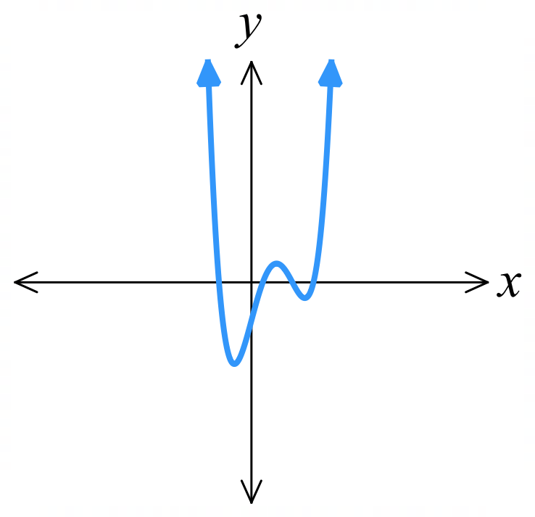  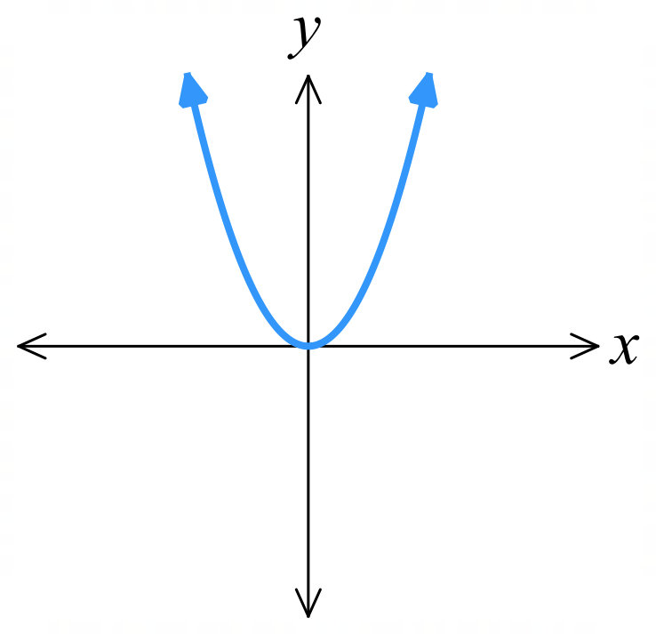  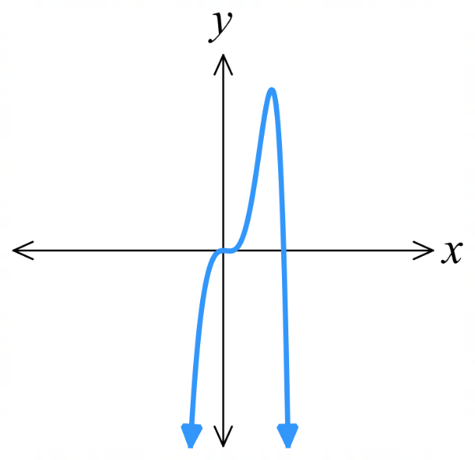
If leading term has odd degree, ends of graph point in different directions.
$$y=1-x^{3}$$ | $$y=x^{3}-10x^{2}+31x-30$$ | $$y=-x^{7}+3x^{4}-x+3$$  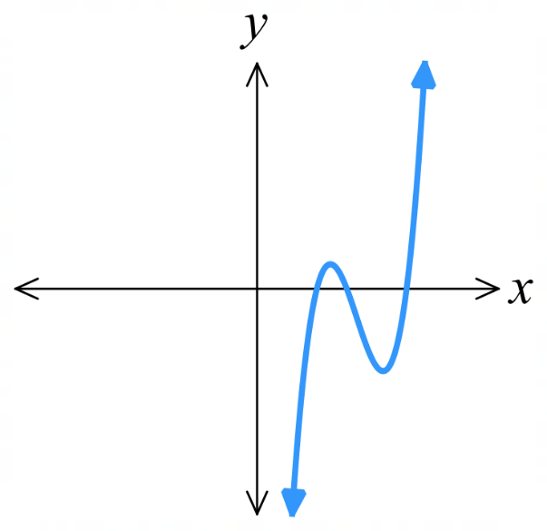  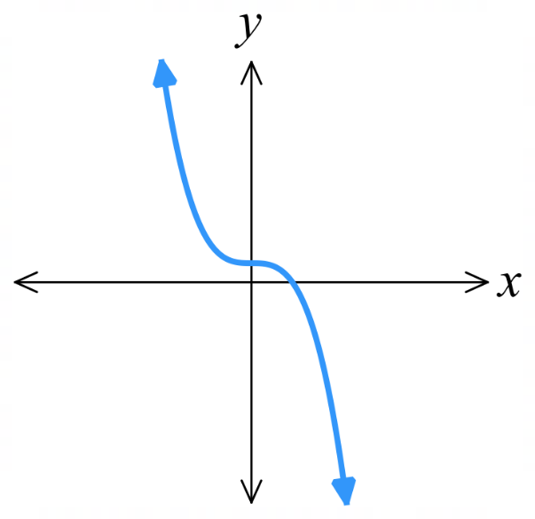  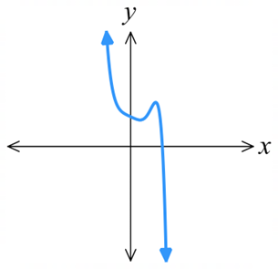
If leading term is positive, as $x→∞, P\left(x\right)→∞$.
$$y=x^{3}+3x^{2}-10x-24$$  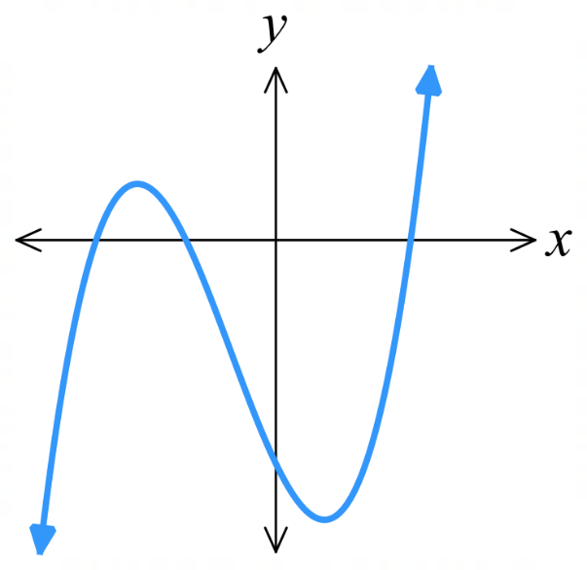 | $$y=2x^{3}+x^{2}-5x+3$$  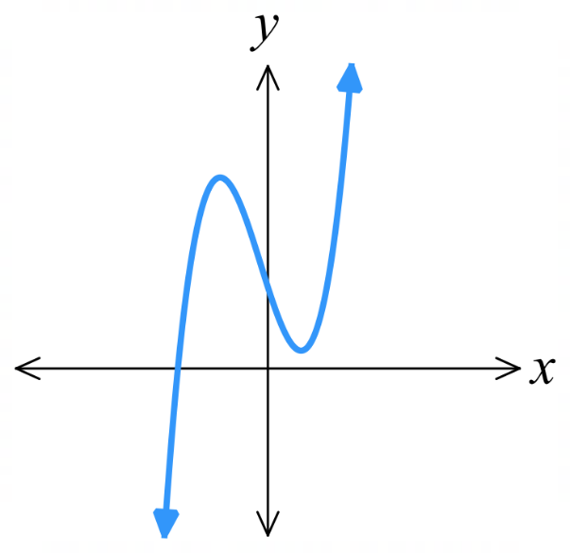 | $$y=x^{4}-3$$  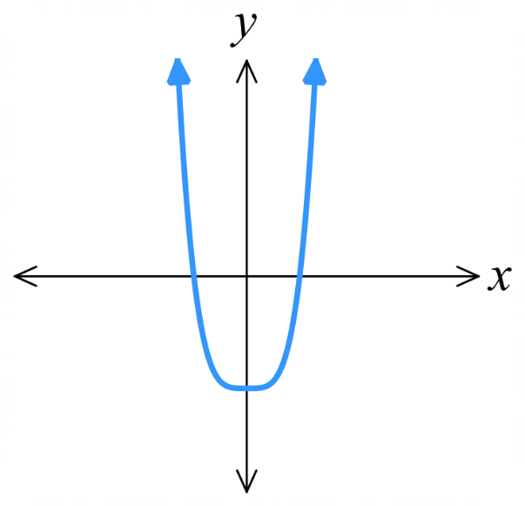
If leading term is negative, as $x→∞, P\left(x\right)→-∞$.
$$y=-x^{3}+8x^{2}-19x+12$$  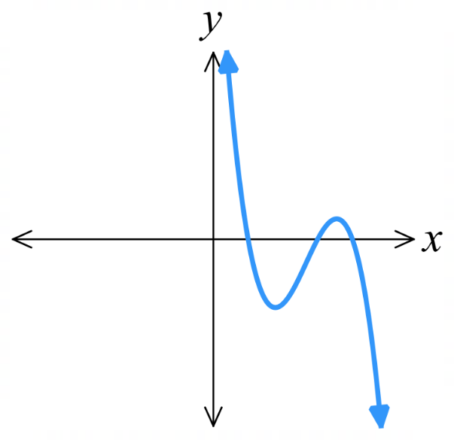 | $$y=-2x^{5}-4x^{2}$$  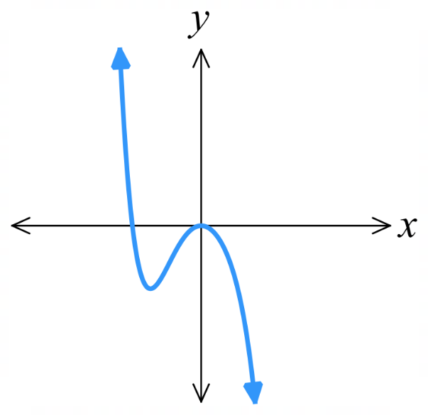 | $$y=8x^{2}-16-x^{4}$$  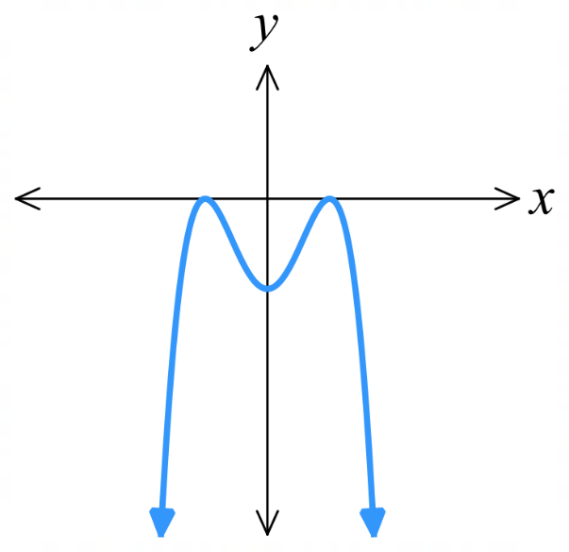

- Identify characteristics of leading term from graph
For each graph of a polynomial, determine whether the leading term is positive or negative, and whether the degree is odd or even.
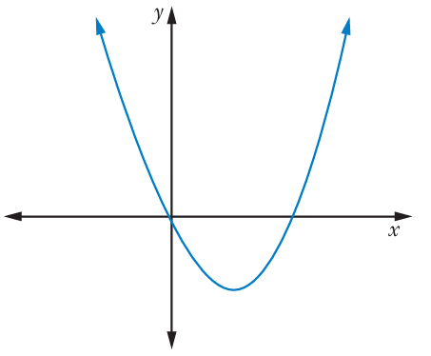  Leading term positive or negative? (circle)  Degree odd or even? (circle) | 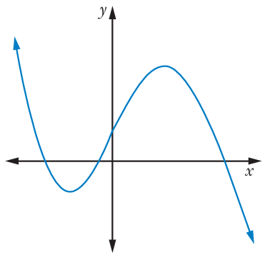  Leading term positive or negative?  Degree odd or even?
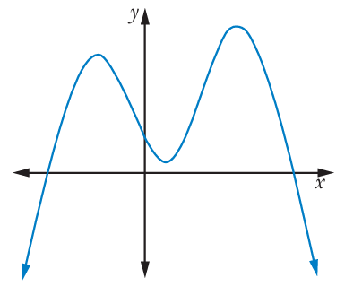  Leading term positive or negative?  Degree odd or even? | 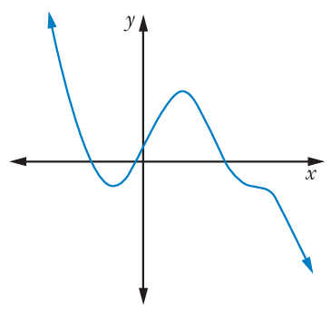  Leading term positive or negative?  Degree odd or even?
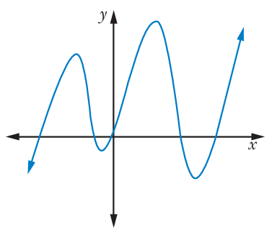  Leading term positive or negative?  Degree odd or even? | 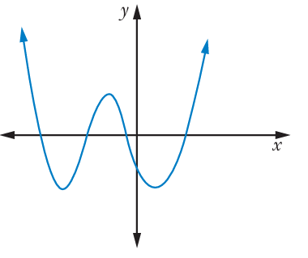  Leading term positive or negative?  Degree odd or even?
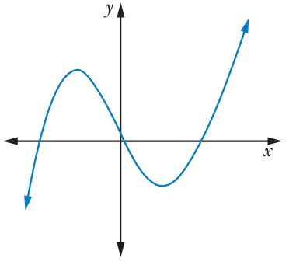  Leading term positive or negative?  Degree odd or even? | 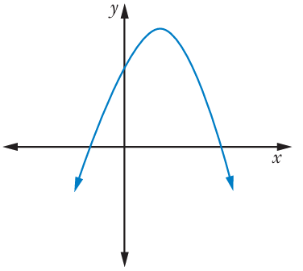  Leading term positive or negative?  Degree odd or even?
- Sketching Polynomials
- A polynomial in factored form is $P\left(x\right)=k\left(x-a\right)\left(x-b\right)\left(x-c\right)(x-d)…$
The $x$-intercepts are at $x=a, b, c, d$ …
- Determine curve behaviour at $x→∞$ (identify leading coefficient).
  - If leading coefficient is positive, then $x→∞$, $y→∞$
  - If leading coefficient is negative, then $x→∞$, $y→-∞$
- Determine the $y$-intercept by letting $x=0$ (multiply constant terms in each factor).
- Determine the $x$-intercepts by letting $y=0$ (use null-factor law).

- Example Sketch polynomials in factored form
Sketch $y=(x-1)(x+3)(x-4)(x+2)$  1. behaviour  Leading term is $x^{4}$,  $x→∞$, $y→∞$  2. $y$-int  $y=\left(-1\right)\left(3\right)\left(-4\right)\left(2\right)=24$  3. $x$-int  $x=1,-3,4,-2$ | 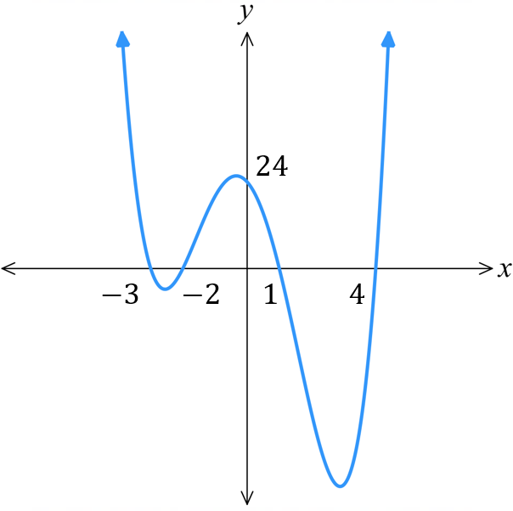  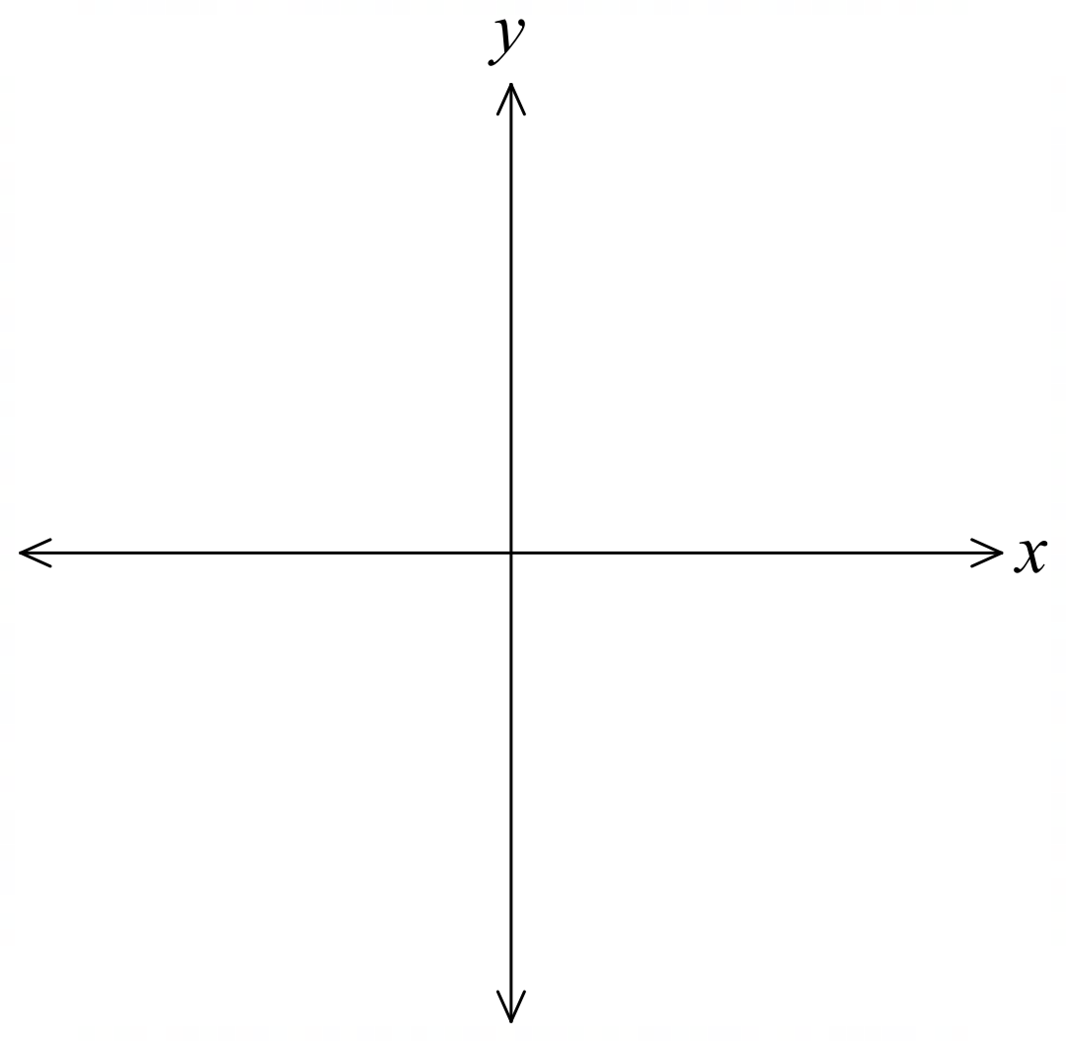

- Guided Practice
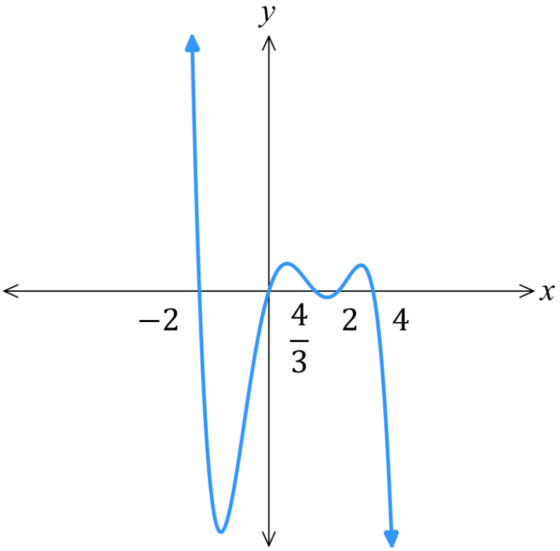
Sketch $y=-x\left(x-3\right)\left(2-x\right)\left(4-3x\right)(x+2)$

Development
- Sketch these polynomial curves. Show the $x$ and $y$-intercepts.
- $y = \left(x-3\right)\left(x+2\right)\left(x-1\right)\left(x+4\right)$ | - $y = -2x\left(x-3\right)\left(x+2\right)\left(x-1\right)$
- $y = -3\left(x-2\right)\left(x+3\right)\left(x-4\right)\left(x+5\right)\left(x-1\right)$ | - $y =x(2x-1)(2-x)(x-3)(x+1)$
- $y = -2\left(2x+3\right)\left(x+1\right)\left(2x-5\right)\left(x-3\right)$ | - $y =\left(3-2x\right)\left(4-x\right)\left(3-x\right)\left(x+3\right)$  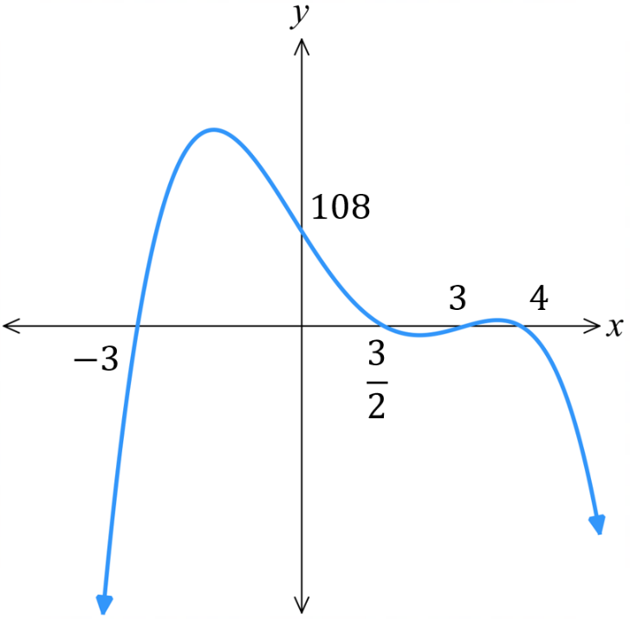  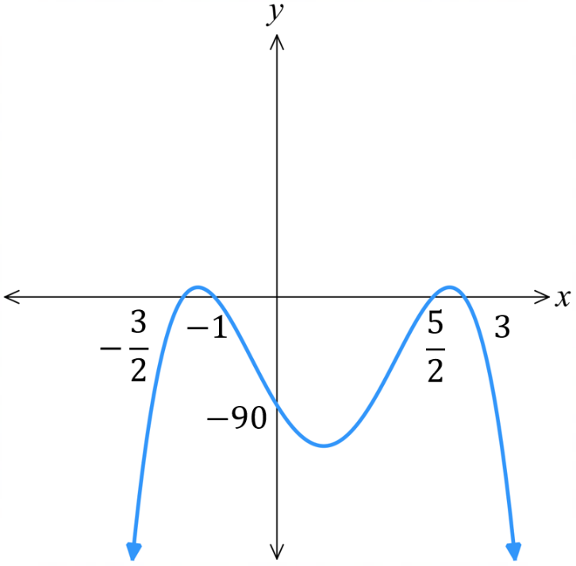  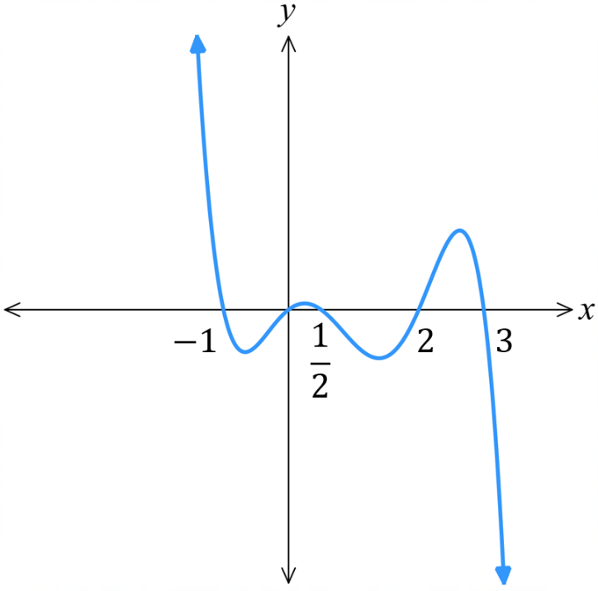  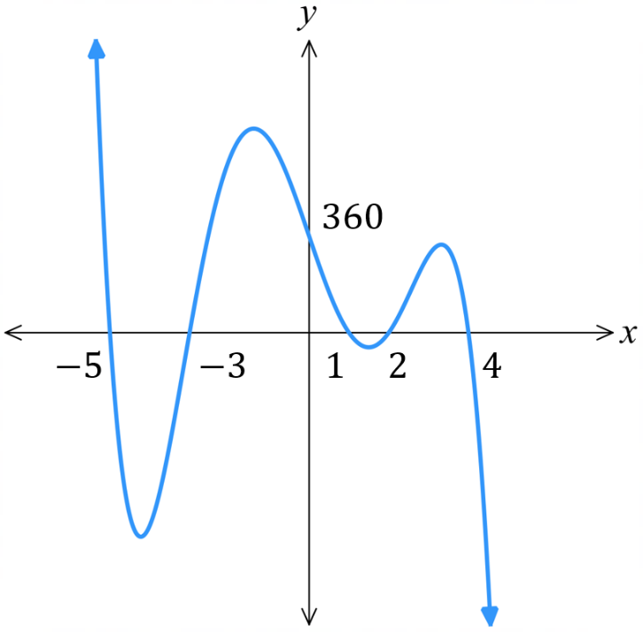  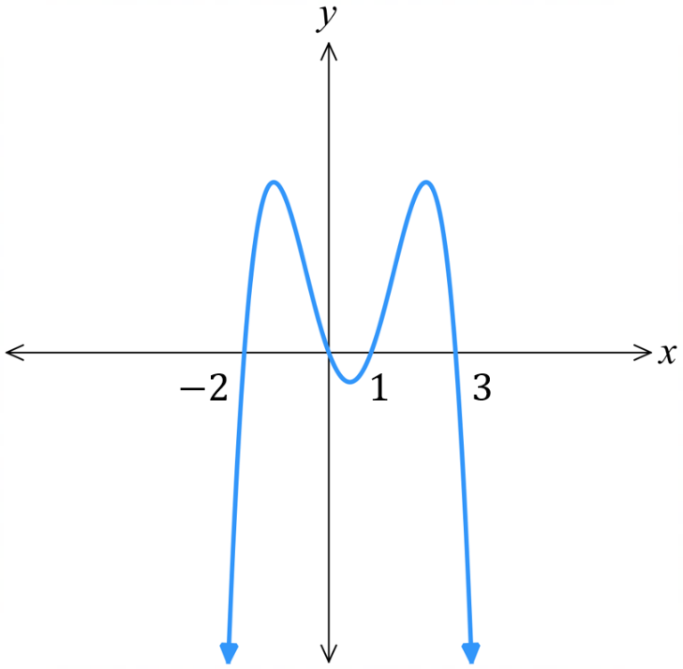  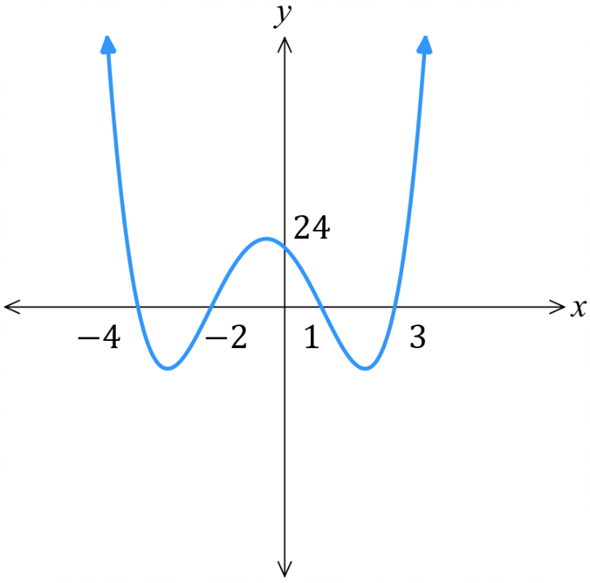

- Sketch, by factorising first.
- $P\left(x\right)=x^{4}+3x^{3}+2x^{2}$  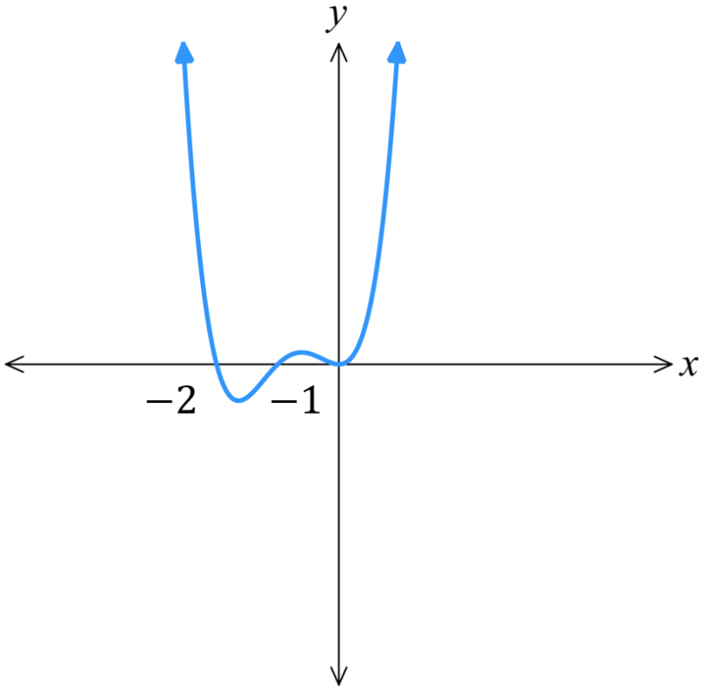  $$P\left(x\right)=x^{2}\left(x+2\right)\left(x+1\right)$$ | - $P\left(x\right)=-x^{3}-4x^{2}+5x$  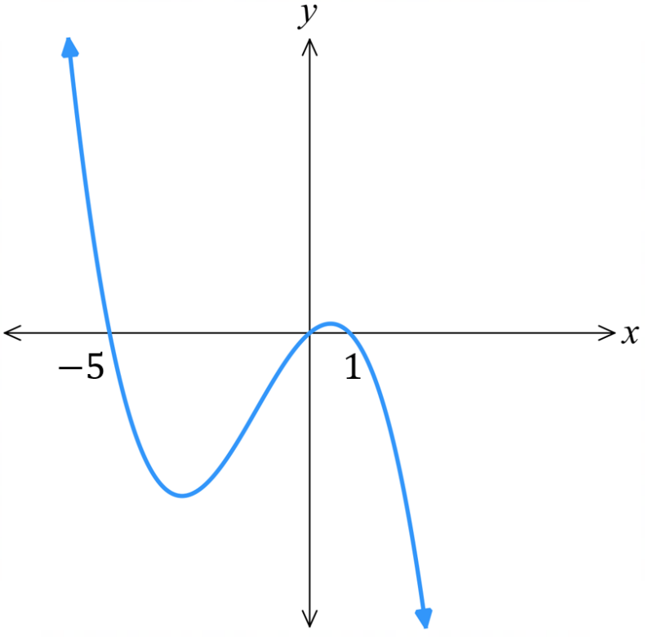  $$P\left(x\right)=-x\left(x+5\right)\left(x-1\right)$$
- $P\left(x\right)=x^{4}-13x^{2}+36$  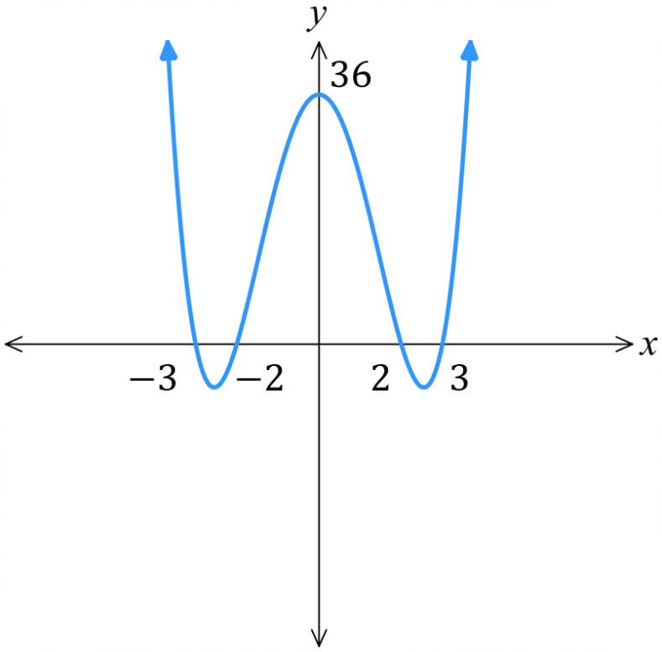  $$P\left(x\right)=\left(x-2\right)\left(x+2\right)\left(x-3\right)\left(x+3\right)$$ | - $P\left(x\right)={\left(x^{2}-5x\right)}^{2}-2\left(x^{2}-5x\right)-24$  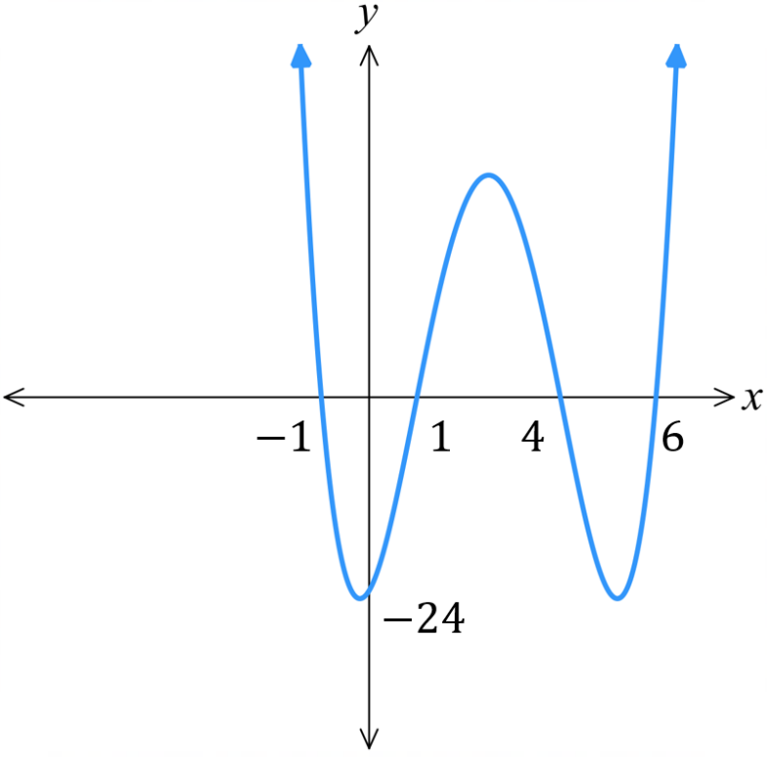  $$P\left(x\right)=\left(x+1\right)\left(x-6\right)\left(x-1\right)\left(x-4\right)$$

Multiplicity of Roots

- Multiplicity of Roots
- A repeated root is called a root of multiplicity.
- For example, if a polynomial is $P\left(x\right)={\left(x-5\right)}^{2}\left(……\right)$, it has a double root at $x=5$, also called root of multiplicity 2.

- Roots of Multiplicity
- https://www.desmos.com/calculator

Sketch:
$y=\left(x-1\right)\left(x-2\right)\left(x+3\right)$
$y=\left(x-1\right){\left(x-2\right)}^{2}\left(x+3\right)$
$y=\left(x-1\right){\left(x-2\right)}^{2}{\left(x+3\right)}^{2}$
$y=\left(x-1\right){\left(x-2\right)}^{2}{\left(x+3\right)}^{3}$
$y={\left(x-1\right)}^{4}{\left(x-2\right)}^{2}{\left(x+3\right)}^{3}$

Explain what happens to the curve at the $x$-intercept when there are repeated roots.

- Multiplicity of Roots
Single Root  The curve “cuts” the axis  like a straight line.  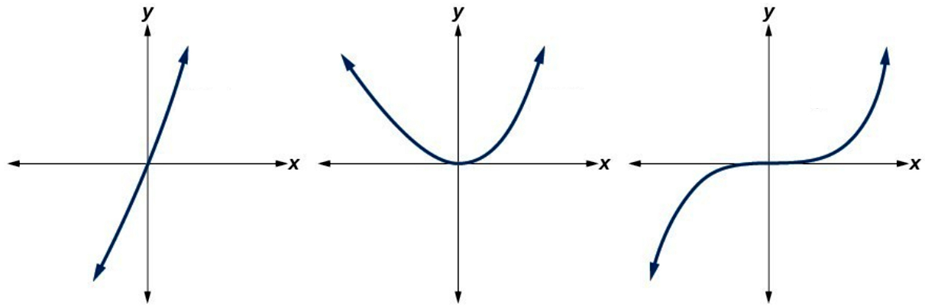 | Double Root  The curve “bounces” off  the axis like a parabola. | Triple Root  The curve inflects along  the axis like a cubic curve.

- Sketching Polynomials with Roots of Multiplicity
- Determine curve behaviour at $x→∞$ (identify leading coefficient).
  - If leading coefficient is positive, then $x→∞$, $y→∞$
  - If leading coefficient is negative, then $x→∞$, $y→-∞$
- Determine the $y$-intercept by letting $x=0$ (multiply constant terms in each factor).
- Determine the $x$-intercepts by letting $y=0$ (use null-factor law).
- Identify the behaviour of the curve at the $x$-intercepts.

- Example Sketch polynomials with repeated roots
Sketch $y=\left(x-3\right){\left(x+1\right)}^{2}$  1. behaviour  Leading term is $x^{3}$ $x→∞$, $y→∞$  2. $y$-int  $y=\left(-3\right){\left(1\right)}^{2}=-3$  3. $x$-int  $x=3, -1$  4. behaviour at roots  Cut at $x=3$  Bounce at $x=-1$ | 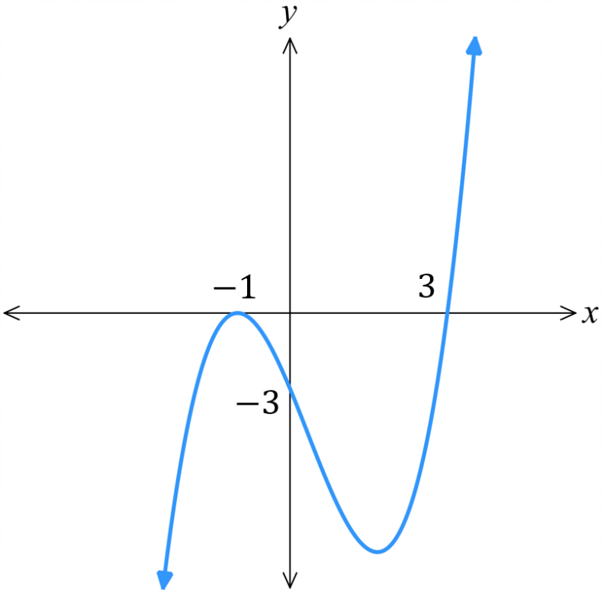
Sketch $y=-{\left(x+1\right)}^{3}\left(x-1\right)(x-3)$  - behaviour  The leading term will be $-x^{5}$ so when $x≈∞$, $y≈-∞$  2. $y$-int  $y=-{\left(1\right)}^{3}\left(-1\right)\left(-3\right)=-3$  - $x$-int  $x=-1, 1, 3$  - behaviour at roots  Inflect at $x=-1$  Cut at $x=1,3$ | 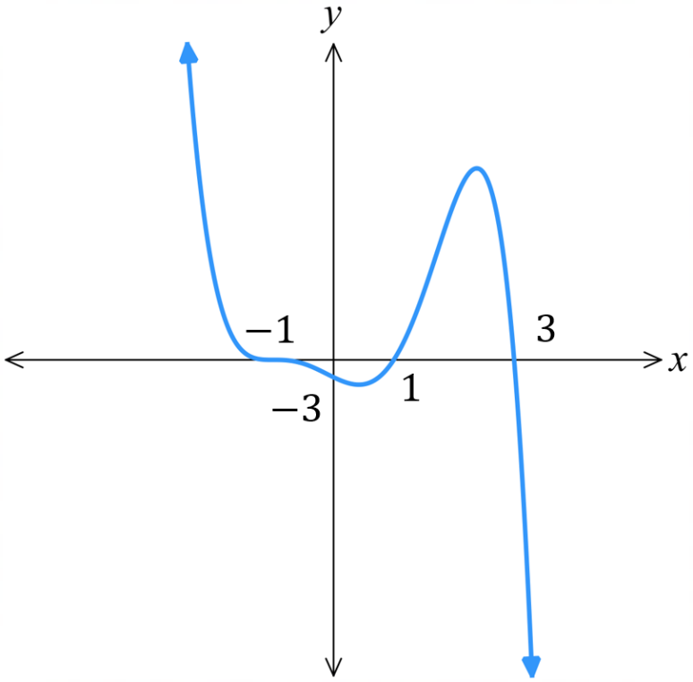

- Guided Practice
Sketch these polynomial functions.
- $y=\left(x-2\right){\left(x+3\right)}^{2}$  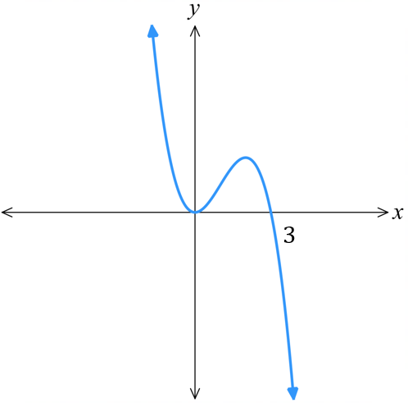  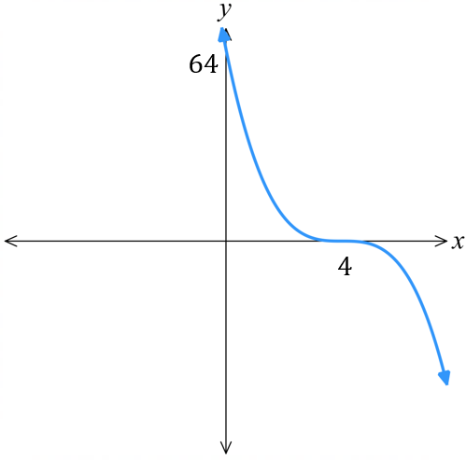  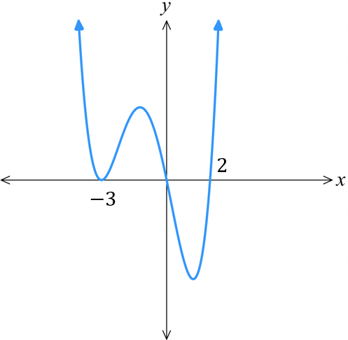  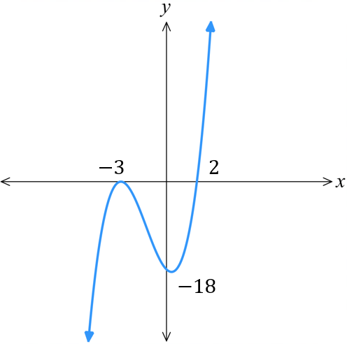 | - $y=x\left(x-2\right){\left(x+3\right)}^{2}$
- $y=-{\left(x-4\right)}^{3}$ | - $y=2x^{2}(3-)$

Foundation
- For each of the following polynomials, state the roots and categorise the root as either:
a single root, double root, or triple root.
- $P\left(x\right)=\left(x-1\right)\left(x+2\right){\left(x-3\right)}^{2}$  $x=1$, single root  $x=-2$, ……… root  $x=3$, ……… root | - $P\left(x\right)=\left(x+1\right)\left(x-3\right)\left(x+5\right)$
- $P\left(x\right)={\left(x-5\right)}^{2}$ | - $P\left(x\right)={\left(x+4\right)}^{3}$
- $P\left(x\right)={\left(x-2\right)}^{2}\left(x+4\right)$ | - $P\left(x\right)={\left(x+7\right)}^{3}\left(x+3\right)$
- $P\left(x\right)={\left(x+7\right)}^{3}{\left(x+3\right)}^{2}\left(x-1\right)$ | - $P\left(x\right)={\left(x^{2}-1\right)}^{2}$  (Hint: the factor must be linear; factorise first)

- Write down, in factorised form, the monic polynomial that has
  - A single root at $x=1, -2,$and $3$ …………………………………………
  - A single root at $x=±1$ and a double root at $x=4$ …………………………………………
  - A double root at $x=2$ and a triple root at $x=-2$ …………………………………………

- Sketch these functions.
- $y={\left(x-4\right)}^{3}$  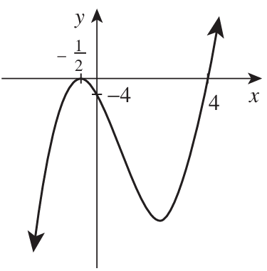  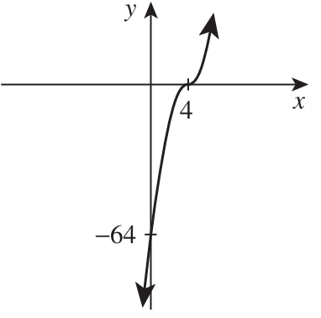 | - $y={\left(2x+1\right)}^{2}\left(x-4\right)$
- $y=x^{2}\left(1-x\right)$  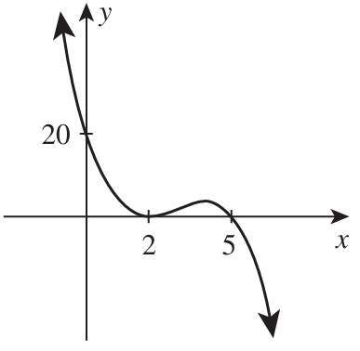  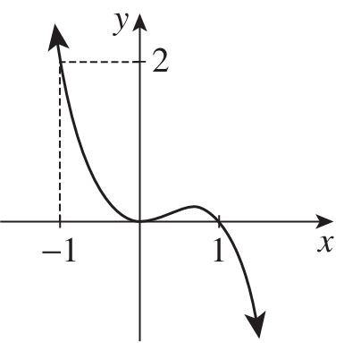 | - $y={\left(2-x\right)}^{2}\left(5-x\right)$
- $y=x^{2}\left(x+4\right)\left(x-3\right)$  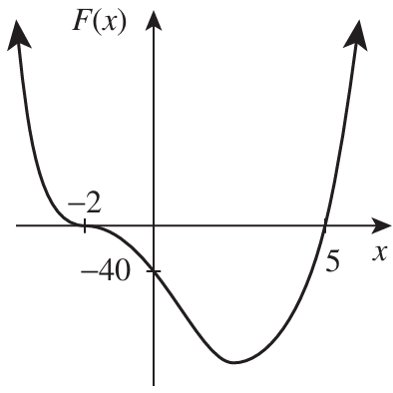  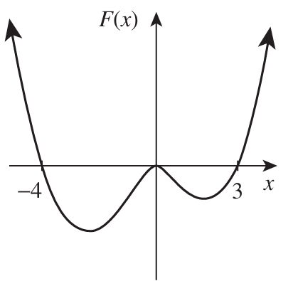 | - $y={\left(x+2\right)}^{3}\left(x-5\right)$

Development
- $y={\left(2x-3\right)}^{2}{\left(x+1\right)}^{2}$  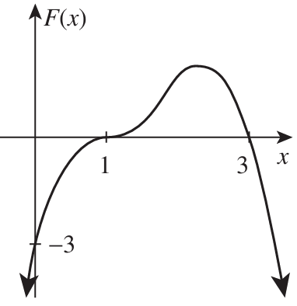  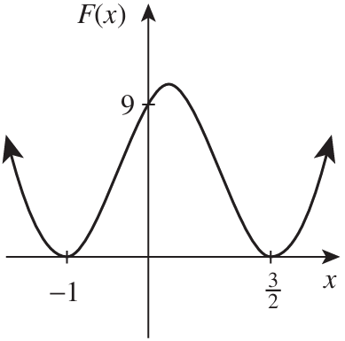 | - $y={\left(1-x\right)}^{3}\left(x-3\right)$
- $y={\left(2-x\right)}^{2}\left(1-x^{2}\right)$  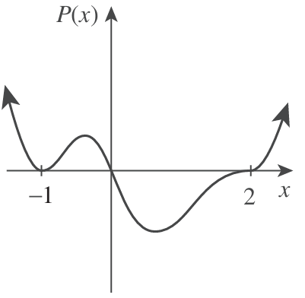  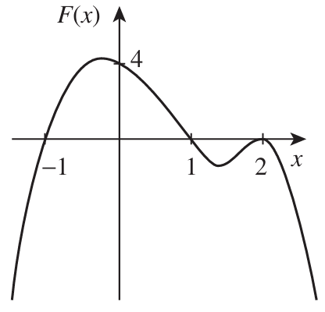 | - $y=x{\left(x-2\right)}^{3}{\left(x+1\right)}^{2}$
- $y=\left(x+1\right)\left(4-x^{2}\right)\left(x^{2}-3x-10\right)$  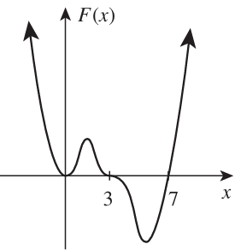  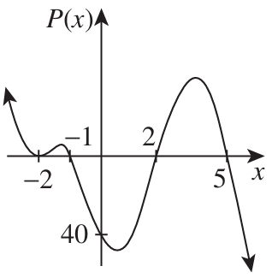 | - $y=x^{2}{\left(x-3\right)}^{3}\left(x-7\right)$

Mastery
- The diagrams below have leading coefficients either $1$ or $-1$.
Write the equation of each polynomial.
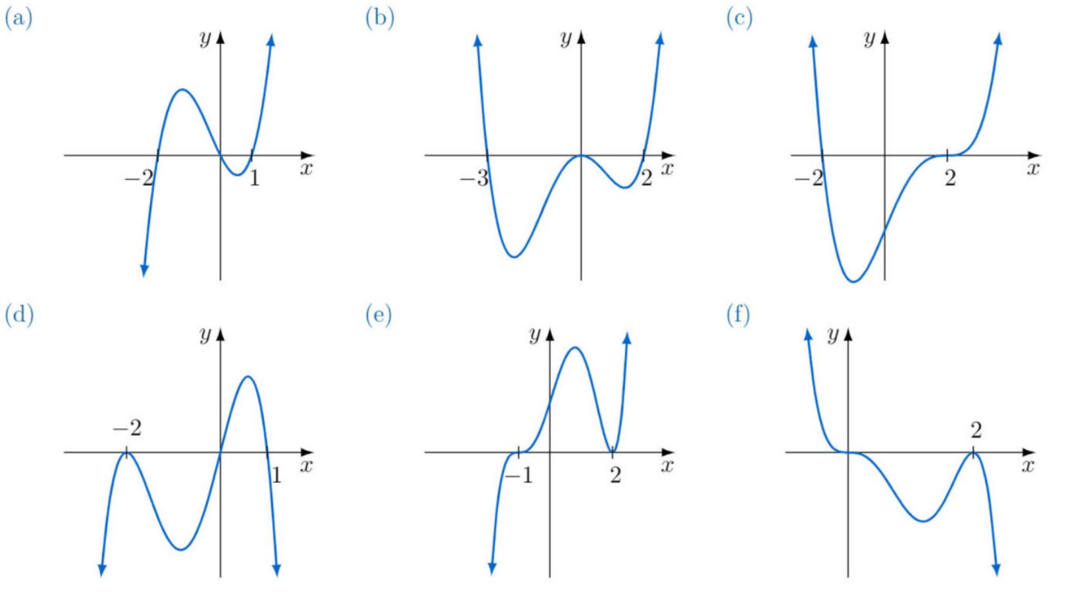  $$P\left(x\right)=x\left(x+2\right)\left(x-1\right)$$ | $$P\left(x\right)=x^{2}\left(x+3\right)\left(x-2\right)$$ | $$P\left(x\right)=\left(x+2\right){\left(x-2\right)}^{2}$$
$$P\left(x\right)=-x\left(x-1\right){\left(x+2\right)}^{2}$$ | $$P\left(x\right)={\left(x-2\right)}^{2}{\left(x+1\right)}^{3}$$ | $$P\left(x\right)=-x^{3}{\left(x-2\right)}^{2}$$
- Given $P\left(x\right)=2x+5$, $Q\left(x\right)=x^{2}-x-2$ and $R\left(x\right)=x^{3}-9x$, find:
- Zeroes of $P(x)$  $$-\frac{5}{2}$$ | - Zeroes of $Q(x)$  $$-1, 2$$ | - Zeroes of $R(x)$  $$0, 3, -3$$
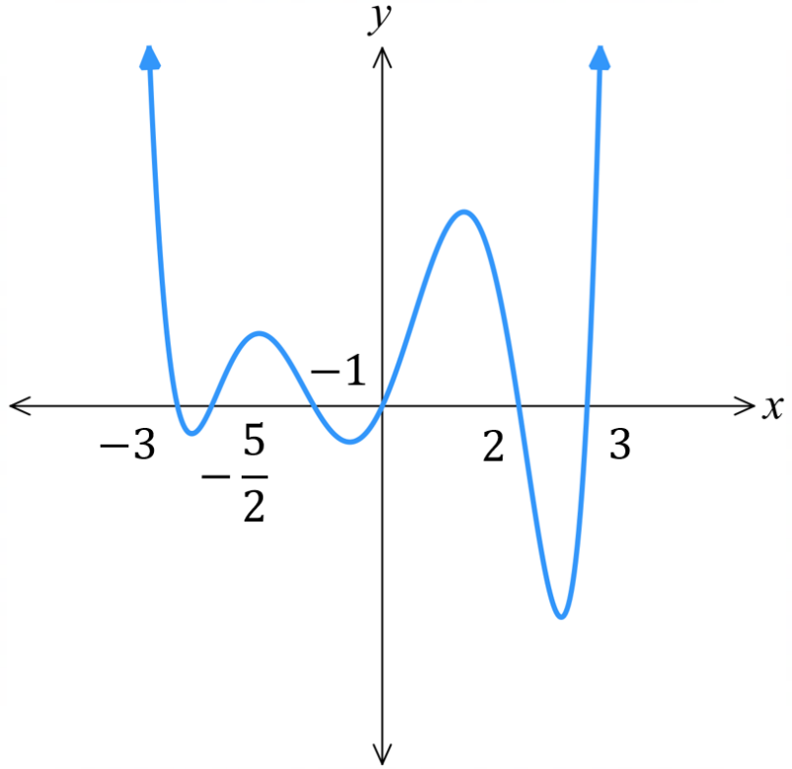
  - Hence identify the zeroes of $P\left(x\right)Q\left(x\right)R(x)$.

$$-\frac{5}{2}, -1, 2, 0, 3, -3$$
  - Hence sketch $P\left(x\right)Q\left(x\right)R(x)$.

- 2021 HSC Advanced Band 4
The graph of $f\left(x\right)$ is shown. Which of the following options could be the equation of this graph?
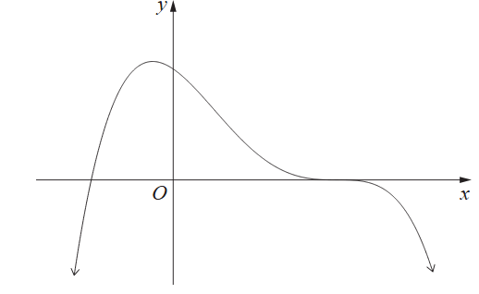
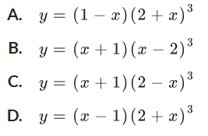

C

- 2023 HSC Advanced Band 4
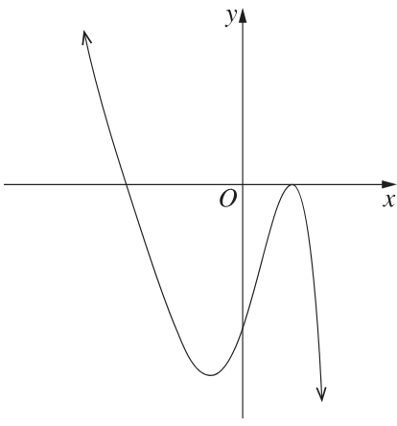
Which row of the table is correct for this cubic curve?
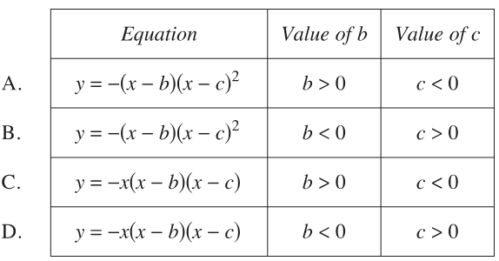

B
- The diagram below shows the graph of a polynomial $y=P\left(x\right)$ with roots $x=-1$ and $x=2$.
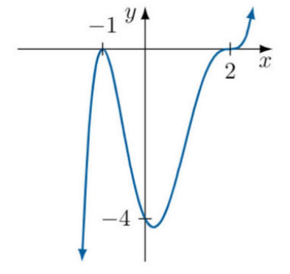
  - Explain why this is a polynomial of the form
$y=a{\left(x+1\right)}^{2}{\left(x-2\right)}^{3}$.

The graph shows a double root at $x=-1$ and a triple root at $x=2$
  - Find the value of $a$ by using the $y$-intercept.

$$a=\frac{1}{2}$$
  - Hence, state the equation of the polynomial.
$$P\left(x\right)=\frac{1}{2}{\left(x+1\right)}^{2}{\left(x-2\right)}^{3}$$
- Use a similar technique to find the equation of these polynomial graphs.
$$y=\frac{1}{8}{\left(x-4\right)}^{3}\left(x+2\right)$$ | 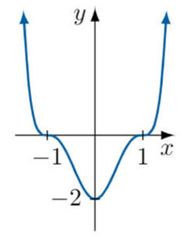  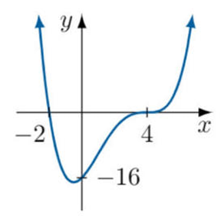  $$y=2{\left(x-1\right)}^{3}{\left(x+1\right)}^{3}$$

- Consider the polynomial $P\left(x\right)=x^{4}-5x^{2}+4x+13$.
  - $P\left(x\right)$ can be expressed in the form ${\left(x^{2}-a\right)}^{2}+{\left(x-b\right)}^{2}$. Find the values of $a$ and $b$.

$$P\left(x\right)={\left(x^{2}-3\right)}^{2}+{\left(x+2\right)}^{2}$$
  - Hence explain why the graph of $P(x)$ has zero $x$-intercepts.

$P\left(x\right)={\left(x^{2}-3\right)}^{2}+{\left(x+2\right)}^{2}$ is a sum of two squares, it will always be positive.

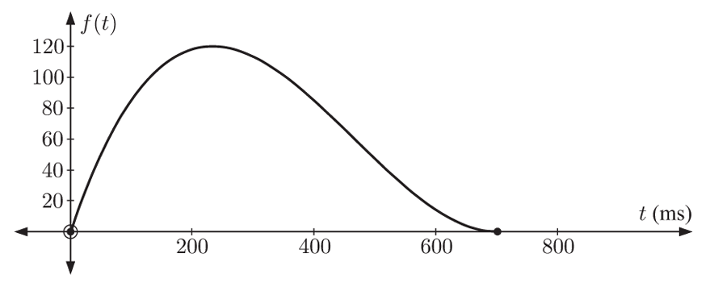
- A scientist is trying to design an ideal crash test barrier with the characteristics shown in the graph below. The independent variable $t$ is time after impact, measured in milliseconds.
The dependent variable is the distance the barrier is depressed during the impact, measured in millimetres.

  - The equation for this graph has the form $f\left(t\right)=kt{\left(t-a\right)}^{2}$. $0≤t≤700$
Use the graph to find the value of $a$ and explain what this represents.

By looking at the zeroes of the graph, $a=700$. It takes 700 milliseconds for the barrier to bounce back to original after the crash.
  - This ideal crash barrier is depressed by 85 mm after 100 milliseconds. Find the value of $k$ that gives this result and hence find the equation of the graph.

Sub $t=100, f\left(t\right)=85$ into the equation to solve for $k$.
$$k=\frac{17}{7200000}$$
$$f\left(t\right)=\frac{17}{7200000}t{\left(t-700\right)}^{2}$$

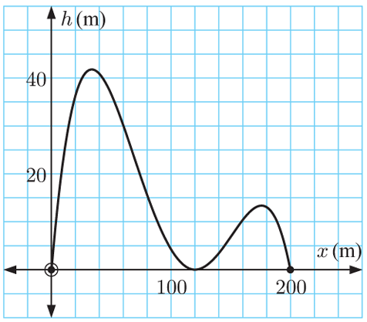
- The graph shows the height in metres of a rollercoaster above the ground against the horizontal distance travelled, also in metres. The equation of this graph is in the form
$$h\left(x\right)=\frac{-x\left(x-a\right){\left(x-b\right)}^{2}}{k}$$
  - Use the graph to find $a$ and $b$.

$$a=200, b=120$$
  - Given the rollercoaster is 4 m above the ground after travelling 100 m, find the value of $k$.

$$k=1 000 000$$
  - Find the height of the rollercoaster above the ground after it has travelled 150 m.

6.75 m

Division of Polynomials

- Language of Division
- Division involves finding how many times a number goes into another number, and the number that is left over.
- We have special terms for these four numbers to make communication clear.
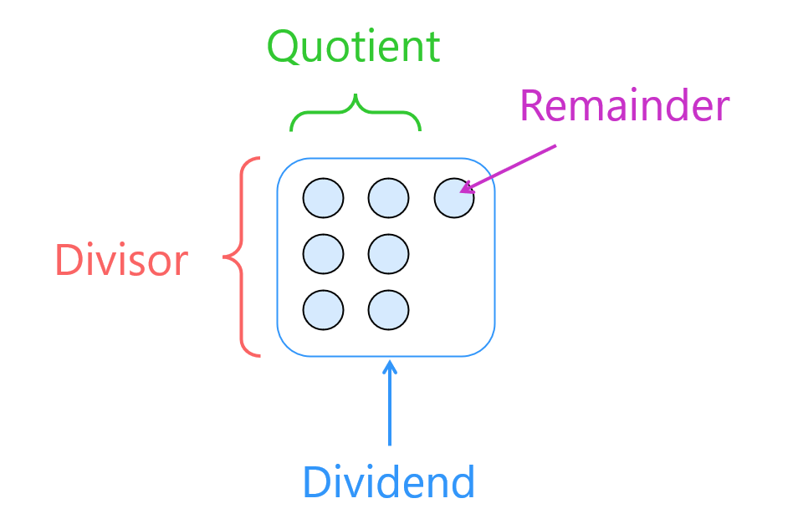
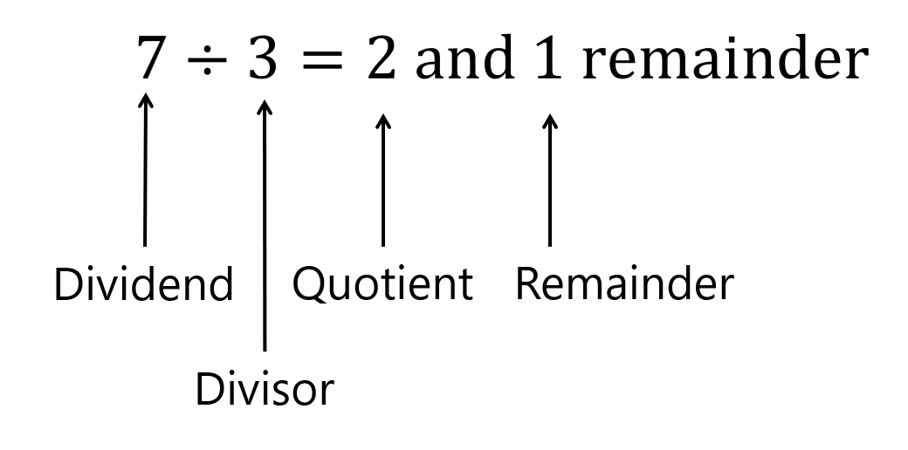

- Example Identify numbers in a division question
$18÷3=6$  18: Dividend  3: Divisor  6: Quotient | $$128÷9=14 r 2$$  Dividend: 128  Divisor 9  Quotient: 14  Remainder: 2

- Guided Practice
Identify the dividend, divisor, quotient, and remainder in these division questions.
- $56÷7=8$  56:  dividend  7:  divisor  8:  quotient | - $63÷3=20 r 2$  3:  divisor  63:  dividend  20:  quotient  2:  remainder | - $39÷5=7 r 4$  4:  remainder  7:  quotient  39:  dividend  5:  divisor
- $51÷17=3$  Divisor:  17  Quotient:  3  Dividend:  51  Remainder:  0 | - $59÷8=7 r 3$  Dividend:  59  Remainder:  3  Divisor:  8  Quotient:  3 | - $78÷9=8 r 2$  Remainder:  2  Quotient:  8  Dividend:  78  Divisor:  9
- Polynomial Division
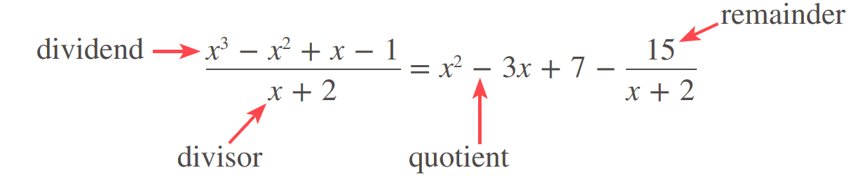

- At each step, divide the leading term of the remainder by the leading term of the divisor.
- We write the result in the following form, with dividend $P(x)$, divisor $D(x)$, quotient $Q(x)$, and remainder $R(x)$:
$$\frac{P\left(x\right)}{D\left(x\right)}=Q\left(x\right)+\frac{R\left(x\right)}{D\left(x\right)}$$

- Example Divide a polynomial by a linear polynomial
$\left(3x^{2}-11x+2\right)÷\left(x-1\right)=3x-8+$ $\frac{-6}{x-1}$
Step 1  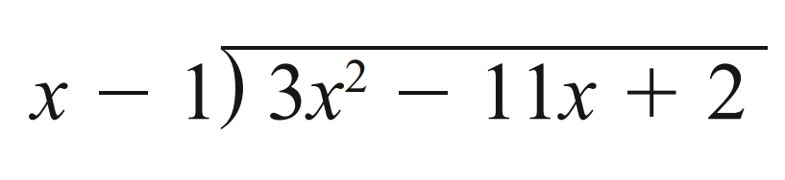 | 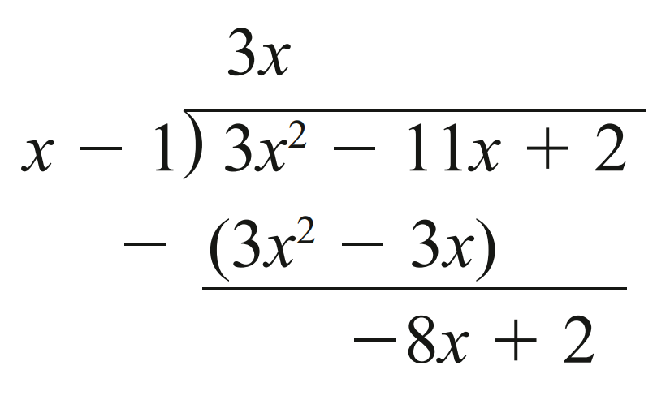  Step 2 | 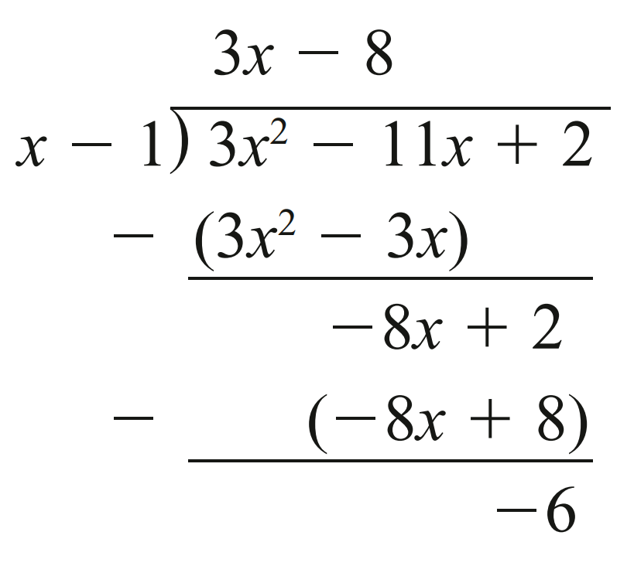  Step 3
$\left(8x^{3}+4x^{2}+12x-5\right)÷\left(2x+1\right)=4x^{2}+6+$ $\frac{-11}{2x+1}$
Step 1  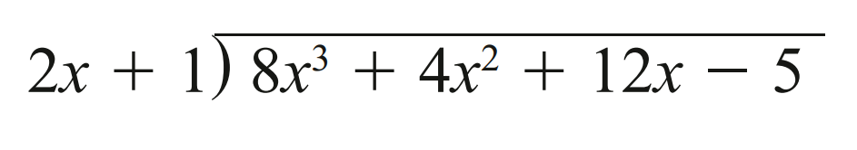 | 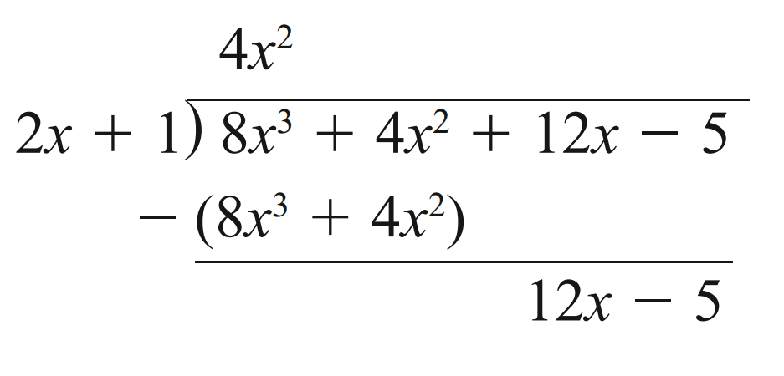  Step 2 | Step 3  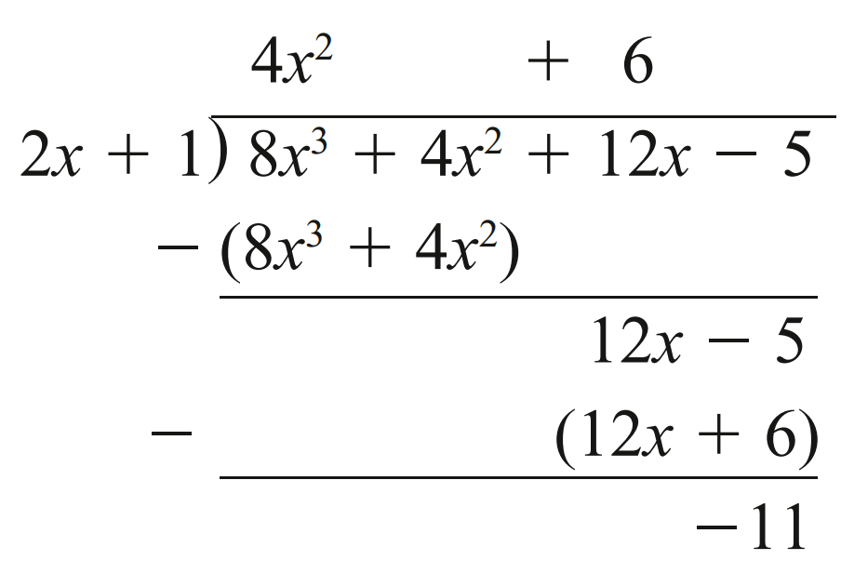

- Guided Practice
Divide these polynomials. Express your answer in the form:
$$\frac{P\left(x\right)}{D\left(x\right)}=Q\left(x\right)+\frac{R\left(x\right)}{D\left(x\right)}$$
- $\left(x^{2}-5x+3\right)÷(x+1)$  $\left(x-6\right)+$ $\frac{9}{x+1}$ | - $\left(x^{2}-2x+5\right)÷(x-4)$  $x+2+$ $\frac{13}{x-4}$
- $\left(x^{3}-x^{2}-17x+24\right)÷(x-4)$  $x^{2}+3x-5+$ $\frac{4}{x-4}$ | - $\left(4x^{3}-4x^{2}+7x+14\right)÷(2x+1)$  $2x^{2}-3x+5+$ $\frac{9}{2x+1}$

Foundation
- Complete these divisions.
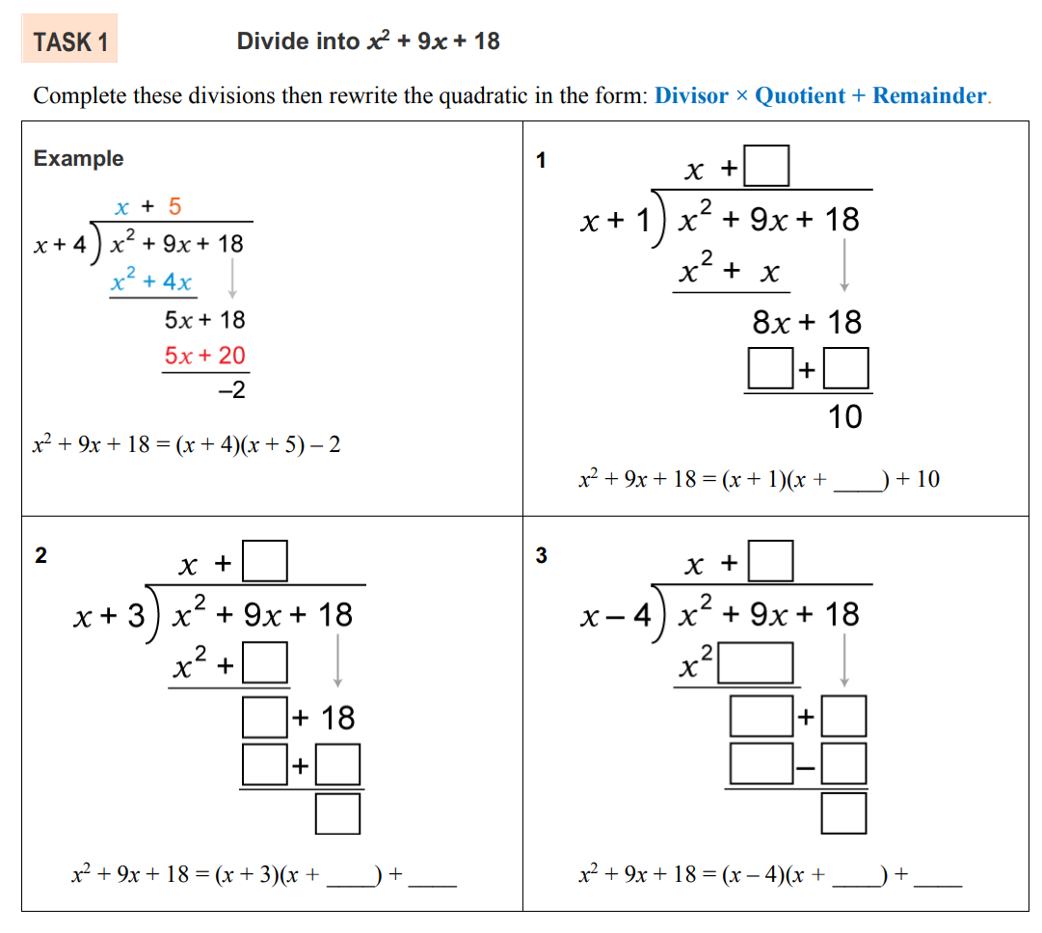  $$-\left( \right)$$  $$-\left( \right)$$  $$\frac{x^{2}+9x+18}{x+4}=\left(x+5\right)+\frac{-2}{x+4}$$ | $$-\left( \right)$$  $$-\left( \right)$$  $$\frac{x^{2}+9x+18}{x+1}=( )+\frac{10}{( )}$$  $$\left(x+8\right)+\frac{10}{x+1}$$
$$-\left( \right)$$  $$-\left( \right)$$  $$x+6$$ | $$-\left( \right)$$  $$-\left( \right)$$  $$\left(x+13\right)+\frac{70}{x+4}$$
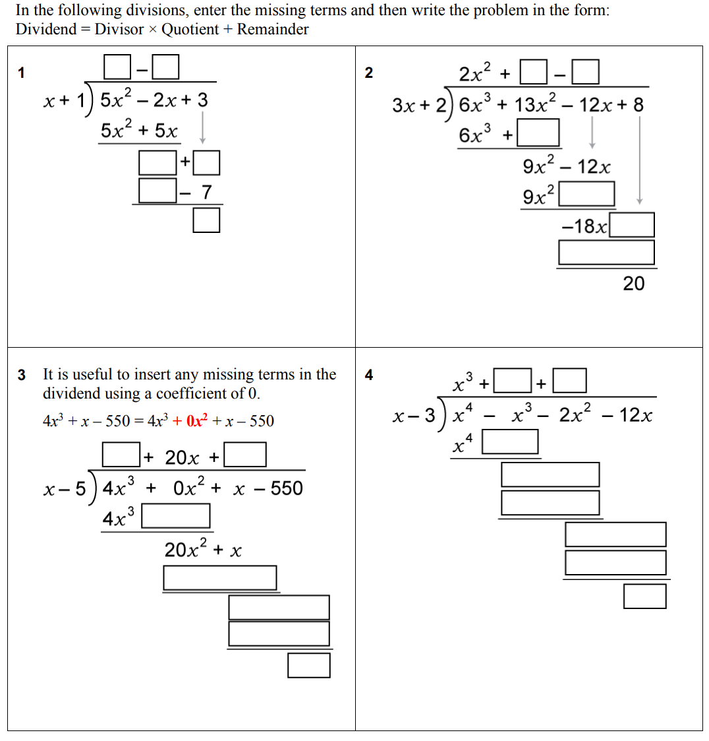  $$-\left( \right)$$  $$-\left( \right)$$  $$\left(5x-7\right)+\frac{10}{x+1}$$ | $$-\left( \right)$$  $$-\left( \right)$$  $$-\left( \right)$$  $$(2x^{2}+3x-6)+\frac{20}{3x+2}$$

$$x^{3}+2x^{2}+4x$$
- Perform the following divisions and express each result in this form
$$\frac{P\left(x\right)}{D\left(x\right)}=Q\left(x\right)+\frac{R\left(x\right)}{D\left(x\right)}$$
- $(x^{2}-4x+1)÷(x+1)$  $$\left(x-5\right)+\frac{6}{x+1}$$ | - $(x^{2}-6x+5)÷(x-5)$  $$x-1$$
- $(2x^{3}+2x^{2}-x-3)÷(x+2)$  $$\left(2x^{2}-2x+3\right)-\frac{9}{x+2}$$ | - $(-x^{3}+x^{2}-10x+4)÷(x-4)$  $$\left(-x^{2}-3x-22\right)-\frac{84}{x-4}$$
- $\frac{4x^{3}-4x^{2}+7x+14}{2x+1}$  $$\left(2x^{2}-3x+5\right)+\frac{9}{2x+1}$$ | - $\frac{x^{4}+x^{3}-x^{2}-5x-3}{x-1}$  $$\left(x^{3}+2x^{2}+x-4\right)-\frac{7}{x-1}$$

Development
- Consider the example $\left(4x^{3}+x-550\right)÷\left(x-5\right)$
This polynomial is missing the $x^{2}$ term. When there are “gaps” in a polynomial, it is useful to insert any missing terms using a coefficient of 0 so you can keep the terms lined up.

$$\left(4x^{2}+2x+101\right)+\frac{450}{x-5}$$
Perform the following divisions and express each result as $\frac{P\left(x\right)}{D\left(x\right)}=Q\left(x\right)+\frac{R\left(x\right)}{D\left(x\right)}$
- $\left(x^{3}-5x+3\right)÷\left(x-2\right)$  $$\left(x^{2}+2x-1\right)+\frac{1}{x-2}$$ | - $\left(2x^{3}+x^{2}-11\right)÷\left(x+1\right)$  $$\left(2x^{2}-x+1\right)-\frac{12}{x+1}$$
- $\frac{2x^{3}-3}{2x-4}$  $$\left(x^{2}+2x+4\right)+\frac{13}{2x-4}$$ | - $\frac{3x^{4}-4x^{3}+4x-9}{x-2}$  $$\left(3x^{3}+2x^{2}+4x+12\right)+\frac{15}{x-2}$$

Mastery
- Divide these polynomials and express in the form $\frac{P\left(x\right)}{D\left(x\right)}=Q\left(x\right)+\frac{R\left(x\right)}{D\left(x\right)}$
- $\left(-2x^{3}-2x^{2}-5x+7\right)÷\left(x+4\right)$  $$-2x^{2}+6x-29+\frac{123}{x+4}$$ | - $\left(-5x^{3}+11x^{2}-2x-20\right)÷\left(x-3\right)$  $$-5x^{2}-4x-14+\frac{-62}{x-3}$$
- $\left(6x^{4}-5x^{3}+9x^{2}-8x+2\right)÷\left(2x-1\right)$  $$3x^{2}-x^{2}+4x-2$$ | - $\left(10x^{4}-x^{3}+3x^{2}-3x-2\right)÷\left(5x+2\right)$  $$2x^{3}-x^{2}+x-1$$
- $\left(x^{3}-5x+3\right)÷\left(x-2\right)$  $$x^{2}+2x-1+\frac{1}{x-2}$$ | - $\left(x^{3}-3x-2\right)÷\left(x+1\right)$  $$x^{2}-x-2$$
- Some more complex questions may require you to divide by a quadratic divisor.
Look at the example and complete the divisions.
- Example Success Criteria
$$\left(3x^{4}-4x^{3}+4x-8\right)÷\left(x^{2}-2\right)$$
Step 1  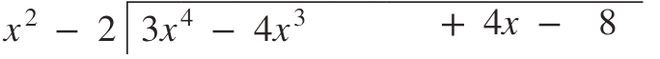 | 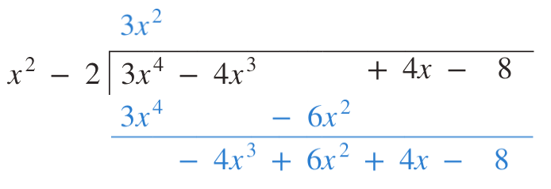  Step 2
Step 3  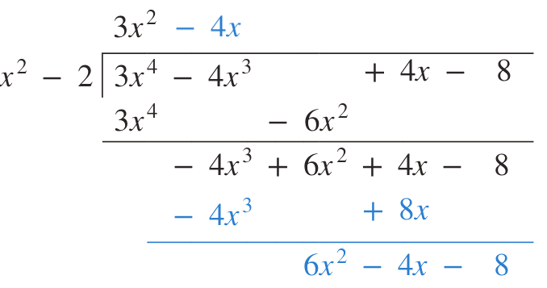 | 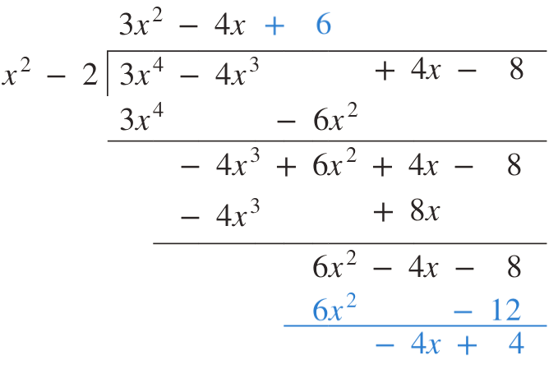  Step 4
$$\left(3x^{2}-4x^{3}+4x-8\right)=3x^{2}-4x+6+\frac{-4x+4}{x^{2}-2}$$

- $(x^{3}-3x^{2}+3x-1)÷(x^{2}+5)$  $$(x-3)+\frac{-2x+14}{x^{2}+5}$$ | - $(2x^{3}+4x^{2}-x+8)÷(x^{2}+3x+2)$  $$(2x-2)+\frac{x+12}{x^{2}+3x+2}$$
- $(2x^{4}-5x^{3}+2x^{2}+2x-5)÷(x^{2}-2x)$  $$(2x^{2}-x)+\frac{2x-5}{x^{2}-2x}$$ | - $\left(x^{5}+x^{3}+5x^{2}-6x+15\right)÷\left(x^{2}+3\right)$  $$x^{3}-2x+5$$

Quotient Remainder Theorem

- Quotient Remainder Theorem
- From primary school, you would have learned that:
If $a÷b=c remainder d$Then $a=c×b+d$

- Inverse relationship between division and multiplication
Fill in the missing numbers.
  - $13÷3=4$ and 1 remainder $→$ $13=$ $4×3+1$
  - $37÷3=12$ and …… remainder $→$ $37=$ …… $×3+1$
  - $96÷7=$ …… and 5 remainder $→$ $93=$ $13×$ …… $+5$
  - $104÷20=5$ and …… remainder $→$ $104=$ …… $×$ …… $+4$
  - $134÷14=9$ and 8 remainder $→$ ……$=$ …… $×$ …… $+$ ……
  - $287÷30=9$ and 17 remainder $→$ ……$=$ …… $×$ …… $+$ ……
  - …… $÷$……$=$ …… and ……remainder$→$ $115=9×12+7$
  - …… $÷$……$=$ …… and ……remainder$→$ $197=15×13+2$
  - …… $÷$……$=$ …… and ……remainder$→$ $23×82+15=1901$

- Quotient Remainder Theorem for Polynomials
- We will apply this idea to polynomials:
Last lesson we used polynomial division to show that, given a dividend $P(x)$, divisor $D(x)$, quotient $Q(x)$, and remainder $R(x)$:
$$\frac{P\left(x\right)}{D\left(x\right)}=Q\left(x\right)+\frac{R\left(x\right)}{D\left(x\right)}$$
- We multiply every term by $D(x)$ to derive the quotient-remainder form of a polynomial:

$$P\left(x\right)=Q\left(x\right)D\left(x\right)+R(x)$$
- Two important facts:
  - The degree of the remainder is always less than the divisor: $\deg{R\left(x\right)}<\deg{D\left(x\right)}$
  - When $R\left(x\right)=0$, then $Q(x)$ and $D(x)$ are factors of $P(x)$: $P\left(x\right)=Q\left(x\right)×D(x)$

- Example Write a polynomial in the form P(x)=Q(x)D(x)+R(x)
Given $\frac{\left(x^{3}+2x^{2}-x+3\right)}{\left(x-2\right)}$ $=\left(x^{2}+4x+7\right)+$ $\frac{17}{x-2}$,
write in the form $P\left(x\right)=\left(x-2\right)Q\left(x\right)+R\left(x\right).$

$$\left(x^{3}+2x^{2}-x+3\right)=\left(x^{2}+4x+7\right)\left(x-2\right)+17$$

- Guided Practice
- Given $\frac{x^{3}-x^{2}+x-1}{x+2}$ $=x^{2}-3x+7-$ $\frac{15}{x+2}$, write in the form $P\left(x\right)=Q\left(x\right)D\left(x\right)+R(x)$  $$\left(x^{2}-3x+7\right)\left(x+2\right)-15$$ | - $\left(x^{2}-5x+3\right)÷\left(x+1\right)=\left(x-6\right)+$ $\frac{9}{x+1}$, write in the form $P\left(x\right)=Q\left(x\right)D\left(x\right)+R(x)$  $$\left(x-6\right)\left(x+1\right)+9$$
- Find $\left(2x^{3}-x^{2}+3x-1\right)÷\left(x+3\right)$ and answer as $P(x)=(x-2)Q(x)+R(x)$.

$$\left(2x^{2}-7x+24\right)\left(x+3\right)-73$$

Foundation
- Complete the equation with the missing numbers.
  - If 182 ÷ 3 = 60 remainder 2, then 182 = ……… × 60 + ………
$$182=3×60+2$$
  - If 2184 ÷ 5 = 436 remainder 4 , then 2184 = ………× 436 + ………
$$2184=5×436+4$$
  - If 617 ÷ 7 = 88 remainder 1, then 617 = 7 × ……… + ……….
$$617=7×88+1$$
- Perform each division and write the answer in the form $p = dq + r$
- $63÷5$  $$63=5×12+3$$ | - $125÷8$  $$125=8×15+5$$ | - $324÷11$  $$324=11×29+5$$

- Divide these polynomials and write in the form $P\left(x\right)=D\left(x\right)Q\left(x\right)+R\left(x\right).$
- $(x^{3}+x^{2}-2x+3)÷(x-1)$  $$x^{3}+x^{2}-2x+3=\left(x-1\right)\left(x^{2}+2x\right)+3$$ | - $(3x^{3}-x^{2}+x+2)÷(x+1)$  $$3x^{3}-x^{2}+x+2=\left(x+1\right)\left(3x^{2}-4x+5\right)-3$$
- $(x^{3}-x^{2}+2x+1)÷(x+1)$  $$x^{3}-x^{2}+2x+1=\left(x+1\right)\left(x^{2}-2x+4\right)-3$$ | - $(x^{4}-3x^{2}+x-2)÷(x-1)$  $$x^{4}-3x^{2}+x-2=\left(x-1\right)\left(x^{3}+x^{2}-2x-1\right)-3$$
- $(x^{3}-x+1)÷(x+2)$  $$x^{3}-x+1=(x^{2}-2x+3)(x+2)+(-5)$$ | - $(x^{3}+x^{2}-3)÷(x-1)$  $$x^{3}+x^{2}-3=(x^{2}+2x+2)(x-1)+(-1)$$
- $(x^{4}-2)÷(x+3)$  $$x^{4}-2=(x^{3}-3x^{2}+9x-27)(x+3)+79$$ | - $(x^{4}-x^{2})÷(x-4)$  $$x^{4}-x^{2}=(x^{3}+4x^{2}+15x+60)(x-4)+240$$

Development
- Divide these polynomials and write in the form $P\left(x\right)=D\left(x\right)Q\left(x\right)+R\left(x\right)$.
- $(3x^{4}-4x^{3}+4x-8)÷(x^{2}-2)$  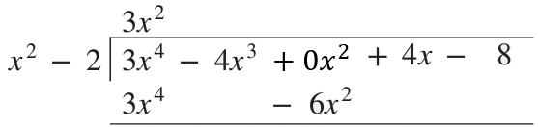  $$3x^{4}-4x^{3}+4x-8=\left(x^{2}-2\right)\left(3x^{2}-4x+6\right)+\left(-4x+4\right)$$ | - $(x^{3}-3x^{2}+x+4)÷(x^{2}-x)$  $$x^{3}-3x^{2}+x+4=\left(x^{2}-x\right)\left(x-2\right)+\left(-x+4\right)$$
- $(x^{3}+x^{2}-7x+6)÷(x^{2}+3x-1)$  $$x^{3}+x^{2}-7x+6=(x^{2}+3x-1)(x-2)+4$$ | - $(x^{4}-3x^{3}+x^{2}-7x+3)÷(x^{2}-4x+2)$  $$x^{4}-3x^{3}+x^{2}-7x+3=(x^{2}-4x+2)(x2+x+3) + (3x-3)$$
- $(x^{3}-3x^{2}+5x-4)÷(x^{2}+2)$  $$x^{3}-3x^{2}+5x-4 =(x^{2}+2)(x-3)+(3x+2)$$ | - $(2x^{3}-3)÷(2x-4)$  $$2x^{3}-3=(2x-4)(x^{2}+2x+4) +13$$
- If the divisor of a polynomial has degree 3, what are the possible degrees of the remainder?

Degree of the remainder must be less than the degree of the divisor.
$∴$ 0, 1, or 2
- On division by $D(x),$ a polynomial has remainder $R(x)$ of degree 2.
What are the possible degrees of $D(x$)?

Degree of remainder must be less than degree of divisor.
$∴$ 3 or higher
- $P\left(x\right)=x^{3}-3x-2$
  - Divide $P\left(x\right)$ by $x+1$

  - Complete the statement: $P\left(x\right)=\left(x+1\right)($……………………$)$.
$$\left(x^{2}-x-2\right)$$
  - Hence, by factorising the quadratic, express $P\left(x\right)$ as the product of three linear factors.

$${\left(x+1\right)}^{2}\left(x-2\right)$$

- Use long division to show that $P(x)=x^{3}+2x^{2}-11x-12$ can be divided by $x-3$ with no remainder and hence express $P(x)$ as the product of three linear factors.

$$x^{3}+2x^{2}-11x-12=\left(x+4\right)\left(x+1\right)\left(x-3\right)$$

Mastery
- 2022 HSC Extension 1 Band 5
$P\left(x\right)$ is a polynomial of degree 5. When $P\left(x\right)$ is divided by a polynomial $Q\left(x\right)$, the remainder is $2x+5$. Which statement is true about the degree of $Q$?
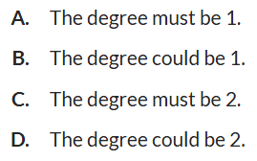

The remainder has degree 1.
The degree of the remainder is smaller than the degree of the divisor.
D.

  - Use long division to show that $P\left(x\right)=2x^{4}+3x^{3}-12x^{2}-7x+6$ is divisible by $x^{2}-x-2$ and express $P\left(x\right)$ as a product of four linear factors.

$$(x-2)(x+1)(2x-1)(x+3)$$

  - Find the quotient and remainder when $x^{4}-2x^{3}+x^{2}-5x+7$ is divided by $x^{2}+x-1$.

quotient: $x^{2}-3x+5$, remainder: $12-13x$
  - Hence find $a$ and $b$ such that $x^{4}-2x^{3}+x^{2}+ax+b$ is exactly divisible by $x^{2}+x-1$.

Consider the long division, the remainder comes from $(ax-3x-5x)+\left(b+5\right)$
We want remainder to be zero, so $ax-3x-5x=0$
$$b+5=0$$
$$∴a=8, b=-5$$
- If $x^{4}-2x^{3}-20x^{2}+ mx + n$ is exactly divisible by $x^{2}-5x+2$, find $m$ and $n$.

From long division, the remainder is $\left(m-41\right)x+\left(n+14\right)$
$$∴m=41, n=-14$$

Remainder Theorem

- Remainder Theorem
For any linear divisor $\left(x-a\right),$
The remainder of $\frac{P\left(x\right)}{(x-a) }$ is $P(a)$.

- Remainder Theorem
Divide $P\left(x\right)=x^{3}-x^{2}+2x-3$ by $(x-2)$

Evaluate $P(2)$ and show that the result is the remainder.

- Example Use remainder theorem to find remainder after division
Find the remainder when $3x^{4}-4x^{3}+4x-8$ is divided by $x-2$
$P\left(x\right)=3x^{4}-4x^{3}+4x-8$
$P\left(2\right)=3{\left(2\right)}^{4}-4{\left(2\right)}^{3}+4\left(2\right)-8$
$=16$

- Guided Practice
Find the remainder when $P\left(x\right)=x^{3}-5x^{2}-x+4$ is divided by:
- $x-2$  $P\left(2\right)=$  $$-10$$ | - $x+1$  $$-1$$
- $x-$ $\frac{1}{2}$  $$\frac{19}{8}$$ | - $x+$ $\frac{2}{3}$  $$\frac{58}{27}$$

Foundation
- Without division, find the remainder when $P\left(x\right)=x^{3}-x^{2}+2x+1$ is divided by:
- $x-1$  $$P\left(1\right)=$$  3 | - $x-3$  25 | - $x+2$  $$-15$$
- $x+1$  $$-3$$ | - $x-5$  111 | - $x+3$  $$-41$$

- Without division, find the remainder when $P\left(x\right)=x^{4}-x^{3}+3x^{2}$ is divided by:
- $x-1$  $$3$$ | - $x-2$  $$20$$ | - $x+2$  $$36$$

- For what value of $k$ will $(x^{4}-2x^{3}+x^{2}-x+k)÷(x+2)$ have zero remainder?
Let $P\left(-2\right)=0$

$-$38
- Find the value of $k$ in these polynomials.
  - When $P(x)=x^{3}+2x^{2}+kx-4$ is divided by $(x-1)$, the remainder is 4.

5
  - When $P(x)=2x^{3}+kx^{2}+3x-4$ is divided by $(x+2)$, the remainder is −6.

5
  - When $P\left(x\right)=kx^{3}+7x^{2}-x-4$ is divided by $(x-2)$, the remainder is −2.

$$-3$$

Development
- For non-monic divisors: $P\left(\frac{b}{a}\right)$ is the remainder when $P\left(x\right)$ is divided by $\left(ax-b\right)$.
Without division, find the remainder when $P(x)=x^{3}+2x^{2}-4x+5$ is divided by:
- $2x-1$  $$P\left(\frac{1}{2}\right)=$$  $$\frac{29}{8}$$ | - $2x+3$  $$\frac{97}{8}$$ | - $3x-2$  $$\frac{95}{27}$$

- The remainder when $P\left(x\right)=(mx^{4}-16x^{3}+6x)$ is divided by $\left(2x+1\right)$ is $-\frac{1}{4}$.
Find the value of $m$.

12
- The remainder when $x^{2}+6x+6$ is divided by $(x-c)$ is 1.
Find the values of $c$ and hence the divisors.

$$c=-5 or-1$$
Divisors are $\left(c+5\right) or \left(x+1\right)$
- The remainder when $x^{2}-x-50$ is divided by $(x-c)$ is $-8$.
Find the values of $c$ and hence the divisors.

$$c=7 or c=-6$$
Divisors are $\left(x-7\right), or \left(x+6\right)$
- Find the divisors of $10x^{2}+3x-25$ that leave a remainder of 2.

$$\left(x-\frac{3}{2}\right) or \left(x+\frac{9}{5}\right)$$

Mastery
- The remainder when $x^{4}-21x^{2}+70$ is divided by $(x-c)$ is $-10$.
Find the values of $c$ and hence the divisors. There are four answers for $c$.
Hint: this a quadratic in disguise.

$$\left(x-4\right) or \left(x+4\right) or \left(x-\sqrt{5}\right) or \left(x+\sqrt{5}\right)$$
- When $P(x)=2x^{3}-x^{2}+ax+b$ is divided by $(x-1)$ the remainder is 16, and
when it is divided by $(x+2)$ the remainder is −17. Find $a$ and $b$ using simultaneous equations

$a=4$ and $b=11$
- $P\left(x\right)=2x^{3}-ax^{2}-bx-1$. The remainder is $-10$ when $P\left(x\right)$ is divided by $\left(x+1\right)$ and $-37$ when $P\left(x\right)$ is divided by $x+2$. Find $a$ and $b$.

$$a=3, b=-4$$
- Prove that, in general, if $P\left(x\right)÷\left(x-a\right)=Q\left(x\right)+$ $\frac{r}{x-a}$, then $P\left(a\right)=r$.
(i.e. prove the remainder theorem)

Multiply both sides by $\left(x-a\right)$
$$P\left(x\right)=\left(x-a\right)Q\left(x\right)+r$$
$$P\left(a\right)=\left(a-a\right)Q\left(a\right)+r$$
$$∴P\left(a\right)=r$$

Factor Theorem

- Factor Theorem
$(x-a)$ is a factor of $P(x)$ if $P\left(a\right)=0$.
$a$ is called a zero of the polynomial.
In general, $\left(ax-b\right)$ is a factor of $P\left(x\right)$ if $P\left(\frac{b}{a}\right)=0$

Fundamental Theorem of Algebra:
A polynomial of degree $n$ has at most $n$ factors.

- Factor Theorem
Divide $P\left(x\right)=x^{3}-{3x}^{2}-3x+10$ by $(x-2)$

Evaluate $P(2)$ and show that it is zero.

Explain how factor theorem is related to remainder theorem:
The remainder theorem states that the remainder of $\frac{P\left(x\right)}{(x-a)}$ is ……………
If $P\left(a\right)=0$, that means there is ……… remainder, hence $(x-a)$ divides evenly into $P(x)$

- Example Use factor theorem to find factors of a polynomial
Show that $(x-3)$ is a factor of $P\left(x\right)=x^{3}-2x^{2}+x-12$ and $(x+1)$ is not.
$P\left(3\right)={\left(3\right)}^{3}-2{\left(3\right)}^{2}+\left(3\right)-12$
$=0$, so $x-3$ is a factor.
$P\left(-1\right)=$ ${\left(-1\right)}^{3}-2{\left(-1\right)}^{2}+\left(-1\right)-12$
$=-16,$so $x-1$ is not a factor.

- Guided Practice
Determine whether each of the following are factors of $P\left(x\right)=x^{3}+x^{2}-3x-6$
- $x+1$  $P\left(-1\right)≠0, (x+1)$not a factor | - $x-2$  $P\left(2\right)=0$, $\left(x-2\right)$ is a factor

Foundation
- What is the remainder when an expression is divided by one of its factors?

0
- Without division, find which of the following are factors of $F(x)=x^{3}+4x^{2}+x-6.$
- $x-1$  yes | - $x+1$  no | - $x-2$  no
- $x+2$  yes | - $x-3$  no | - $x+3$  yes

- Without division, find which of the following are factors of $F\left(x\right)=x^{4}-2x^{3}-25x^{2}+26x+120.$
- $x-2$  no | - $x+2$  yes | - $x+3$  no
- $x-4$  no | - $x+4$  yes | - $x-5$  yes

  - Find the value of $k$ if $(x+2)$ is a factor of $x^{3}-kx^{2}-2x-4$

$$-2$$
  - Find the value of $k$ if $(x-3)$ is a factor of $2x^{3}+2x^{2}-kx-3$

23
  - Find $m$, if $-2$is a zero of the function $F(x)=x^{3}+mx^{2}-3x+4$.

$$-\frac{1}{2}$$
  - For what value of $a$ is $3x^{4}+ax^{2}-2$ divisible by $x+1$?

$$-1$$

Development
- Prove that $(x^{2}-4)$ is a factor of $P\left(x\right)=x^{4}+2x^{3}-3x^{2}-8x-4$ without performing a division.

$$x^{2}-4=\left(x-2\right)\left(x+2\right)$$
$P\left(2\right)=0$ and $P\left(-2\right)=0$
$∴$ $x^{2}-4$ is a factor as $(x-2)$ and $\left(x+2\right)$ are factors.
- Prove that $x^{n}-1$ is always divisible by $\left(x-1\right)$.

Let $P\left(x\right)=x^{n}-1$
$$P\left(1\right)=1^{n}-1$$
Since $1^{n}$ always equals $1$,
$$P\left(1\right)=0$$
- When the polynomial $P(x)$ is divided by $(x-1)(x+3)$, the quotient is $Q(x)$ and the remainder is $(2x+5)$.
  - Write this information in quotient-remainder form $P\left(x\right)=Q\left(x\right)D\left(x\right)+R(x)$

$$P(x)=(x-1)(x+3)Q(x)+(2x+5)$$
  - Hence, by evaluating $P(1),$ find the remainder when $P(x)$ is divided by $(x-1)$.

$$7$$
  - What is the remainder when $P(x)$ is divided by $(x+3)$?

$$-1$$

- When $P\left(x\right)$ is divided by $\left(x^{2}-9\right)$, the remainder is $\left(2x+5\right)$
  - Write the above in the form of $P\left(x\right)=D\left(x\right)Q\left(x\right)+R\left(x\right)$

$$P(x)=(x^{2}-9)Q(x)+(2x+5)$$
  - Hence, find the remainder when $P\left(x\right)$ is divided by $\left(x+3\right)$

$$-1$$
- The polynomial $P(x)$ is divided by $(x-1)(x+2).$
Suppose that the quotient is $Q(x)$ and the remainder is $R(x).$
  - Explain why $R(x)$ must be in the form $ax + b$, where $a$ and $b$ are constants.

The divisor has degree 2, so the remainder has degree 0 or 1.
  - If $P(1)=2$ and $P(-2)=5$, find $a$ and $b$.

$$a=-1, b=3$$
- The polynomial $P(x)$ is given by $P(x) = x^{3} + ax^{2}+bx-18$.
Find $a$ and $b$ given that $(x+2)$ is a factor of $P(x)$,
and $-24$ is the remainder when $P(x)$ is divided by $x-1$.

$$P\left(-2\right)=0$$
$$P\left(1\right)=-24$$
$a=2$ and $b=-9$
- The polynomial $P(x)$ is divided by $(x+4)(x-3)$.
Find the remainder if $P(-4)=11$ and $P(3)=-3$.

$$P\left(x\right)=\left(x+4\right)\left(x-3\right)Q\left(x\right)+ax+b$$
$$P\left(-4\right)=11$$
$$P\left(3\right)=-3$$
Solve simultaneously, $a=-2, b=3$
$$3-2x$$
- Find the values of $m$ and $n$ if $\left(x-1\right)$ and $\left(x-2\right)$ are factors of $P\left(x\right)=x^{4}+mx+n$

$$m=-15, n=14$$

Mastery
- When a polynomial $P\left(x\right)$ is divided by $\left(x-2\right)\left(x+5\right)$, the remainder is $\left(x+3\right)$.
  - Write the division identity $P\left(x\right)=D\left(x\right)Q\left(x\right)+R\left(x\right)$ from this information.

Let $P\left(x\right)=\left(x-2\right)\left(x+5\right)Q\left(x\right)+\left(x+3\right)$
  - Find the remainder when $P(x)$ is divided by $\left(x+5\right)$.

$$P\left(-5\right)=-2$$
- 2012 HSC Extension 1 Band 4
When the polynomial $P\left(x\right)$ is divided by $\left(x+1\right)\left(x-3\right)$, the remainder is $2x+7$.
What is the remainder when $P(x)$ is divided by $x-3$?

$$P\left(x\right)=\left(x+1\right)\left(x-3\right)Q\left(x\right)+2x+7$$
$$P\left(3\right)=\left(x+1\right)\left(3-3\right)Q\left(x\right)+2\left(3\right)+7$$
$=13$
- When a polynomial is divided by $(2x+1)(x-3)$, the remainder is $3x-1$.
What is the remainder when the polynomial is divided by $2x+1$?

Let $P\left(x\right)=\left(2x+1\right)\left(x-3\right)Q\left(x\right)+\left(3x-1\right)$
$$P\left(-\frac{1}{2}\right)=2.5$$

- 2014 HSC Extension 1 Band 4
The remainder when $P\left(x\right)=x^{4}-8x^{3}-7x^{2}+3$ is divided by $x^{2}+x$ is $ax+3$.
What is the value of $a$?

$$P\left(x\right)=x\left(x+1\right)Q\left(x\right)+ax+3$$
$$P\left(-1\right)={\left(-1\right)}^{4}-8{\left(-1\right)}^{3}-7{\left(-1\right)}^{2}+3$$
$=5$
$$P\left(-1\right)=-1\left(-1+1\right)Q\left(-1\right)+a\left(-1\right)+3$$
$=-a+3$
$$∴5=-a+3$$
$$a=-2$$
- A polynomial gives a remainder of $1$ when divided by $(x +1)$, and a remainder of $5$ when divided by $(x-3)$. What is the remainder when the same polynomial is divided by
$$(x+1)(x-3)?$$

$$P\left(x\right)=\left(x+1\right)\left(x-3\right)Q\left(x\right)+ax+b$$
$$P\left(-1\right)=1$$
$$P\left(3\right)=5$$
$$a=1, b=2$$
$∴$ remainder is $x+2$

- When $x^{5}+3x^{3}+ax+b$ is divided by $x^{2}-1$, the remainder is $2x-7$. Find $a$ and $b$.

$$P\left(x\right)=\left(x-1\right)\left(x+1\right)Q\left(x\right)+2x-7$$
$$P\left(1\right)=1^{5}+3{\left(1\right)}^{3}+a\left(1\right)+b=2\left(1\right)-7$$
$$∴4+a+b=-5$$
$$P\left(-1\right)={\left(-1\right)}^{5}+3{\left(-1\right)}^{3}+a\left(-1\right)+b=2\left(-1\right)-7$$
$$∴-4-a+b=-9$$
Solving simultaneously, we get
$$a=-2, b=-7$$
- When a polynomial $P\left(x\right)$ is divided by $x^{2}-5$, the remainder is $x+4$.
Find the remainder when $P\left(x\right)+P\left(-x\right)$ is divided by $x^{2}-5$

$P\left(x\right)=\left(x^{2}-5\right)Q\left(x\right)+x+4$
$P\left(-x\right)=\left({\left(-x\right)}^{2}-5\right)Q\left(-x\right)+\left(-x\right)+4$
$=\left(x^{2}-5\right)Q\left(-x\right)-x+4$
$$P\left(x\right)+P\left(-x\right)=\left(x^{2}-5\right)Q\left(x\right)+x+4+\left(x^{2}-5\right)Q\left(-x\right)-x+4$$
$=\left(x^{2}-5\right)Q\left(x\right)+\left(x^{2}-5\right)Q\left(-x\right)+8$
$=\left(x^{2}-5\right)\left(Q\left(x\right)+Q\left(-x\right)\right)+8$
$∴$ remainder is 8

- $P\left(x\right)$ is an odd polynomial of degree 3.
It has $x+4$ as a factor, and when divided by $x-3$ the remainder is 21. Find $P\left(x\right)$.
Hint: what terms can an odd polynomial have?

Odd polynomial must be in the form $ax^{3}+bx$ (odd powers only for $P\left(-x\right)=P\left(x\right)$
By solving simultaneously $P\left(3\right)=21$ and $P\left(-4\right)=0$,
$$a=-1, b=16$$
$$∴P\left(x\right)=-x^{3}+16x$$

- Find $p$ so that $\left(x-p\right)$ is a factor of $4x^{3}-\left(10p-1\right)x^{2}+\left(6p^{2}-5\right)x+6$.

$$P\left(p\right)=4p^{3}-\left(10p-1\right)p^{2}+\left(6p^{2}-5\right)p+6=0$$
$p^{2}-5p+6=0$
$\left(p-2\right)\left(p-3\right)=0$
$∴p=2, 3$

- Find the real number $a$ such that $\left(x-1-a\right)$ is a factor of $P\left(x\right)=x^{3}-3ax-9$.

$$P\left(1+a\right)={\left(1+a\right)}^{3}-3a\left(1+a\right)-9=0$$
$$a^{3}-8=2$$
$$a=2$$

Solving Polynomial Equations

- Integer Root Theorem
If all coefficients of $P(x)$ are integers, then all integer roots (if they exist) are factors of the constant term.

$P\left(x\right)=x^{3}+2x^{2}-5x-6=\left(x+1\right)\left(x-2\right)\left(x+3\right),$
the integer roots are factors of $-6$

$$P\left(x\right)=x^{3}+x^{2}+x+6=\left(x+2\right)\left(x^{2}-x+3\right),$$
the integer root is a factor of $6$

- Example Find integer roots using factor theorem
Find linear factors of $x^{3}-2x^{2}-2x-3=0$
Test $±1,±3$
$P\left(1\right)=6≠0$ $∴x-1$ not a factor.
$P\left(-1\right)=-4≠0$ $∴x+1$ not a factor.
$P\left(3\right)=0$ $∴x-3$ is a factor.
$P\left(-3\right)=-4≠0$ $∴x+3$ not a factor.

- Guided Practice
Use the factor theorem and trial and error to find ONE linear factor of these polynomials.
- $P(x)=x^{3}+2x^{2}+7x+6$  $\left(x+1\right)$ is a factor | - $P(x)=x^{3}+2x^{2}-x-2$  $\left(x-2\right), \left(x-1\right), \left(x+1\right)$ are factors | - $P(x)=x^{3}+x^{2}+x+6$  $\left(x+2\right)$ is a factor
Use the factor theorem to find all three linear factors of each of these polynomials.
- $P(x)=x^{3}-2x^{2}-x+2$  $$\left(x-2\right)\left(x-1\right)\left(x+1\right)$$ | - $P(x)=x^{3}-2x^{2}-5x+6$  $$\left(x-1\right)\left(x+2\right)\left(x-3\right)$$ | - $P(x)=x^{3}-4x^{2}+x+6$  $$\left(x+1\right)\left(x-2\right)\left(x-3\right)$$
- Solving Polynomials
- To solve a polynomial, we can factorise it and use the null factor law.
- Use integer root theorem to find an integer zero $x=a$ of $P(x).$
- Then use polynomial long division to factor $P(x)$ in the form $P\left(x\right)=\left(x-a\right)Q(x)$
- Factorise $Q\left(x\right)$.
- Solve for $x$ using null factor law.

- Example Factorise a polynomial using factor theorem
Solve $P\left(x\right)=x^{3}+2x^{2}-5x-6=0$
1. Find integer root
Test factors of $-6:$
$P\left(1\right)=-8$, so $(x-1)$ is not a factor.
$P\left(-1\right)=0$ , so $(x+1)$ is a factor.
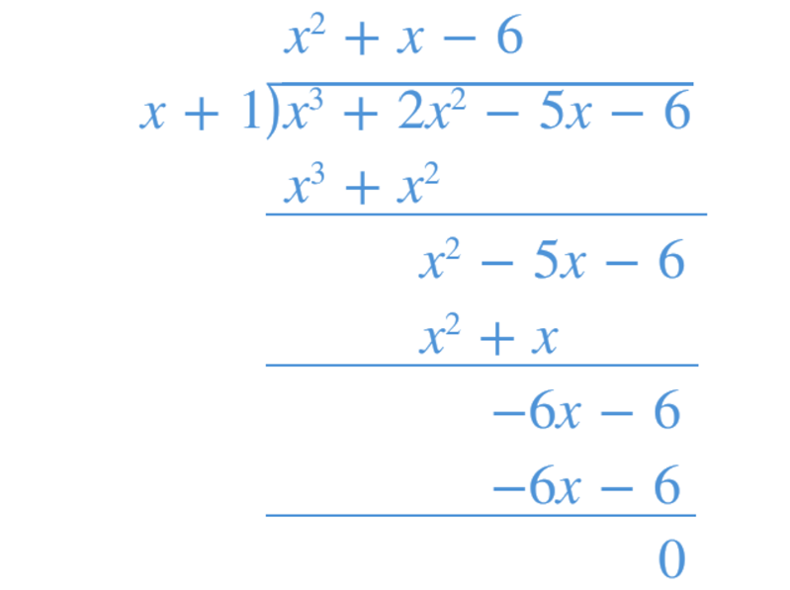
2. Long division

$P\left(x\right)=\left(x+1\right)\left(x^{2}+x-6\right)$
3. Factorise
$P\left(x\right)=\left(x+1\right)\left(x+3\right)\left(x-2\right)$
4. Solve
$P\left(x\right)=\left(x+1\right)\left(x+3\right)\left(x-2\right)=0$
$∴x=-1,-3, 2$

- Guided Practice
Factorise these polynomials, and hence solve $P\left(x\right)=0$
- $P\left(x\right)=x^{3}-4x^{2}+x+6$  $$x=-1,2,3$$ | - $P\left(x\right)=x^{3}+6x^{2}-x-30$  $$x=-5,-3,2$$
- $P\left(x\right)=2x^{3}-13x^{2}+13x+10$  $$x=-\frac{1}{2}, 2, 5$$ | - $P\left(x\right)=x^{3}+4x-5$  $x=1$ only real solution

- Key Ideas
- The integer root theorem says that if all coefficients of $P(x)$ are integers, then all integer roots (if they exist) are factors of the …………… term.
- We can use factor theorem and ………-and-………… to find integer roots of a polynomial.
- After finding a root, we can factorise a polynomial by …………… ………………

Foundation
- $P\left(x\right)=x^{3}-3x-2$
  - Show that $\left(x+1\right)$ is a factor of $P\left(x\right)$.
$$P\left(-1\right)={\left(-1\right)}^{3}-3\left(-1\right)-2=0$$
  - Hence by using long division, write: $P\left(x\right)=(x+1)($…………………$)$

$$P\left(x\right)=\left(x+1\right)\left(x^{2}-x-2\right)$$
  - By factorising the resultant quadratic, express $P\left(x\right)$ as a product of linear factors.

$$P\left(x\right)={\left(x+1\right)}^{2}\left(x-2\right)$$
- For each of the following cubic equations, follow these steps.
- Use the factor theorem to find a factor.
- Use long division to find the quotient.
- Factorise the quotient.
- Write the polynomial in a fully factorised form.
- Solve for $x$ using the null factor law.
- $x^{3}-4x^{2}+x+6=0$  $$x=-1, 2, 3$$ | - $x^{3}-6x^{2}+11x-6=0$  $$x=1,2,3$$
- $x^{3}-3x^{2}-16x-12=0$  $$x=-2, -1, 6$$ | - $2x^{3}-3x^{2}=11x-6$  $$x=-2, 0.5, 3$$

- Solve by first taking out a common factor.
- $2x^{3}-14x^{2}+14x+30=0$  $$x=-1, 3, 5$$ | - $3x^{3}+12x^{2}+3x-18=0$  $$x=-3, -2, 1$$

- $P\left(x\right)=2x^{3}-9x-27$
  - Show that $x-3$ is a factor of $P\left(x\right)$

$$P\left(3\right)=2{\left(3\right)}^{3}-9\left(3\right)-27=0$$
  - Hence by using long division, write: $P\left(x\right)=(x-3)($…………………$)$

$$\left(x-3\right)\left(2x^{2}+6x+9\right)$$
  - By using the discriminant, show that $3$ is the only real zero of this polynomial.

$Δ$ of $2x^{2}+6x+9$ is $Δ=6^{2}-4\left(2\right)\left(9\right)<0$
So $x=3$ is the only zero.
- Explain why $\left(x-2\right)\left(x^{2}-3x+3\right)=0$ has only one real solution.

$Δ$ of $x^{2}-3x+3$ is $Δ={\left(-3\right)}^{2}-4\left(1\right)\left(3\right)<0$
- Explain why $x^{4}+x^{2}=0$ has only one real solution.

$$x^{4}+x^{2}=x^{2}\left(x^{2}+1\right)$$
$$x^{2}=0, x=0$$
$$x^{2}+1=0, x^{2}=-1$$
No real solution for $x^{2}=-1$, so only real solution is $x=0$
- Show that $P\left(x\right)=x^{3}+x+3$ does not have an integer zero by testing all the possible integer zeros.

Test $P\left(-3\right), P\left(-1\right), P\left(1\right), P\left(3\right)$. None give zero.
- Use the quadratic formula to solve for $x$, expressing your answers in exact form.
- $(x-1)(x^{2}-2x-4)=0$  $$x=1, 1±\sqrt{5}$$ | - $(x+2)(x^{2}+6x+10)=0$  $$x=-2$$

- Solve for $x$ without long division by factorising first.
- $x^{3}-x^{2}=0$  $$x=0, 1$$ | - $x^{3}-x^{2}-12x=0$  $$x=-3, 0, 4$$ | - $2x^{5}+4x^{4}+2x^{3}=0$  $$x=-1, 0$$

  - Show that $P(x)=x^{3}-8x^{2}+9x+18$ is divisible by both $(x-3)$ and $(x+1)$.
$$P\left(3\right)=0$$
$$P\left(-1\right)=0$$
  - By considering the leading term and constant term, express $P(x)$ as a product of three linear factors and hence solve $P\left(x\right)=0$

$$\left(x-3\right)\left(x+1\right)\left(x-6\right)$$
$$x=3, -1, 6$$

Development

  - Show that $P(x)=2x^{3}-x^{2}-13x-6$ is divisible by both $(x-3)$ and $(2x+1)$.
$$P\left(3\right)=0$$
$$P\left(-\frac{1}{2}\right)=0$$
  - By considering the leading term and constant term, express $P(x)$ as a product of three linear factors and hence solve $P\left(x\right)=0$

$$\left(2x+1\right)\left(x-3\right)\left(x+2\right)$$
$$x=-2, -\frac{1}{2}, 3$$
- A fast way of factorising polynomials is by equating coefficients.
Suppose you know that $3x^{3}-8x^{2}-x+10=\left(x+1\right)\left(ax^{2}+bx+c\right)$
Step 1: Compare leading coefficients to find $a$:
The coefficient of $x^{3}$ on the LHS is ……
3
The coefficient of $x^{3}$ on the RHS would be …………
$$a$$
Therefore, $a=$ ……
3
Step 2: Compare constant terms to find $c$:
The constant term on the LHS is ……
10
The constant term on the RHS would be …………
$$c$$
Therefore, $c=$ ……
10
Step 3: Rewrite with values of $a$ and $c$:
$3x^{3}-8x^{2}-x+10=\left(x+1\right)\left(3x^{2}+bx+10\right)$

Step 4: Equate other coefficients to find $b$:
The coefficient of $x$ on the LHS is ……
$$-1$$
The coefficient of $x$ on the RHS would be …………………
$$b+10$$
Therefore, $b=$ ……

$$-11$$
Step 5: Rewrite and factorise.
$3x^{3}-8x^{2}-x+10=\left(3x^{2}-11x+10\right)\left(x+1\right)$
$=\left(3x-5\right)\left(x-2\right)\left(x+1\right)$

- Factorise by equating coefficients, given $x^{3}+x^{2}-4x-4=\left(x+1\right)\left(ax^{2}+bx+c\right)$

$$\left(x+1\right)\left(x-2\right)\left(x+2\right)$$
- Show that $\left(2x-1\right)$ is a factor of $P\left(x\right)=6x^{3}+23x^{2}-33x+10$.
Then fully factorise $P\left(x\right)$ (by long division or comparing coefficients) and state the zeros.

$$\left(2x-1\right)\left(3x-2\right)\left(x+5\right)$$
- $P\left(x\right)=x^{3}-6x+4$
  - Find a factor of $P\left(x\right)$ using the factor theorem by testing the factors of $4$.
  - Express $P\left(x\right)$ as the product of a linear and quadratic factor.
  - Hence solve $P\left(x\right)=0$.

$$x=2, -1±\sqrt{3}$$
- $P\left(x\right)=2x^{3}+x^{2}-13x+6.$ Evaluate $P\left(0.5\right)$ and hence find the zeroes of $P\left(x\right)$.

$$x=\frac{1}{2}, -3, 2$$

Mastery
- $P\left(x\right)=6x^{3}+x^{2}-5x-2$. Evaluate $P\left(-\frac{2}{3}\right)$ and hence find the zeroes of $P\left(x\right)$.

$$x=-\frac{2}{3}, -\frac{1}{2}, 1$$
- Use trial and error to find as many integer zeroes of $P\left(x\right)$ as possible,
then use long division to find the other factors.
- $P(x)=2x^{4}-5x^{3}-5x^{2}+5x+3$  $$(x-1)(x+1)(x-3)(2x+1)$$ | - $P(x) = 6x^{4}-25x^{3}+17x^{2}+28x-20$  $$(2x-5)(3x-2)(x+1)(x-2)$$
- Suppose $6x^{3}+ax^{2}-11x+15=\left(2x-5\right)\left(px^{2}+qx+r\right)$.
Find $a,p,q,r$ by equating coefficients.

$$p=3, r=-3, q=1, a=-13$$
- A box is to be built with a square base and height 2 cm more than the length of the base.
  - Write an expression for the volume of the box.
  - If the volume is to be 45 cm³, write a polynomial equation modelling this scenario.
  - Find the dimensions that will give this volume.
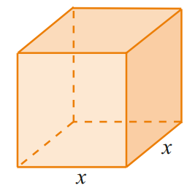

a) $x^{2}\left(x+2\right)$
b) $x^{3}+2x^{2}-45=0$
c) $x=3$
$∴$ 3 cm x 3 cm x 5 cm

- Four identical squares are cut from the corners of a rectangular sheet of metal 8 cm x 10 cm.
The sides are folded up along the dotted lines to form a rectangular box, as shown.
  - Find an expression for the volume of the box.
  - Find the side length of the square that should be cut from each corner if the volume is to be 48 cm³.
  - Hence state the dimensions of the rectangular box with this volume.
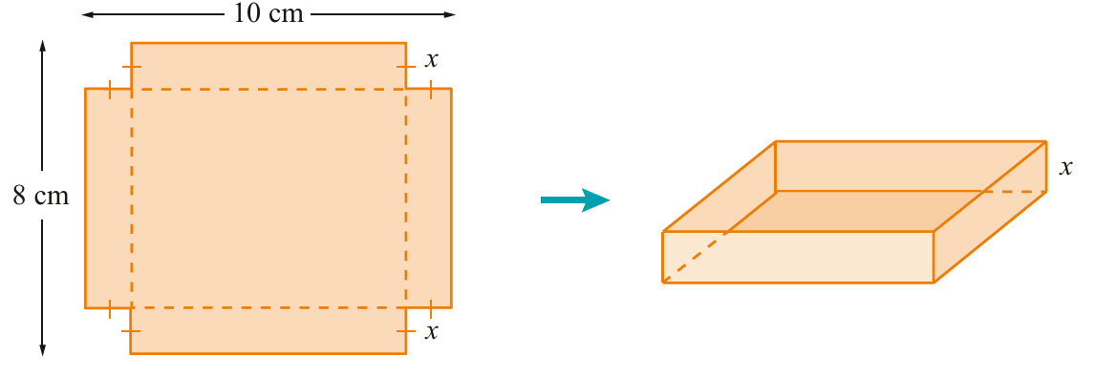

a) $x(8-2x)(10-2x)$
b) $4x^{3}-36x^{2}+80x-48=0$
c) $x=1$ or $2$
$∴$8 x 6 x 1 or 6 x 4 x 2 cm

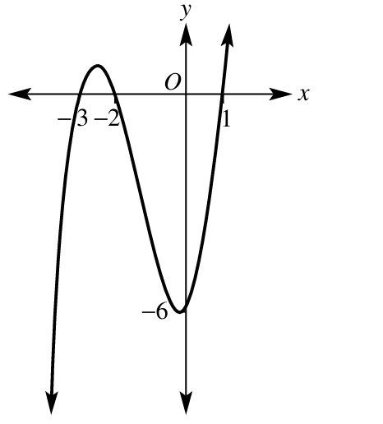
- Factorise these polynomials using factor theorem and/or long division. Then sketch the graphs.
  - $P\left(x\right)=x^{3}+4x^{2}+x-6$

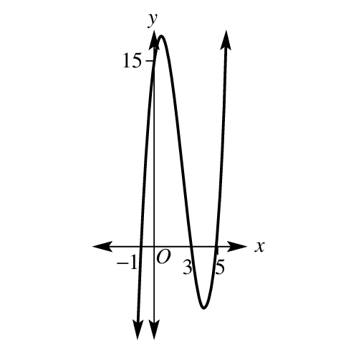
$P\left(x\right)=(x-1)(x+2)(x+3)$
  - $P\left(x\right)=x^{3}-7x^{2}+7x+15$

$$P\left(x\right)=(x-5)(x-3)(x+1)$$
  - $P\left(x\right)=x^{4}+2x^{3}-9x^{2}-2x+8$
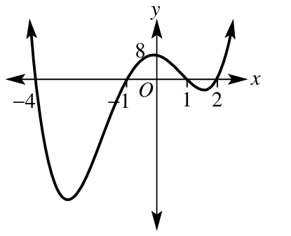

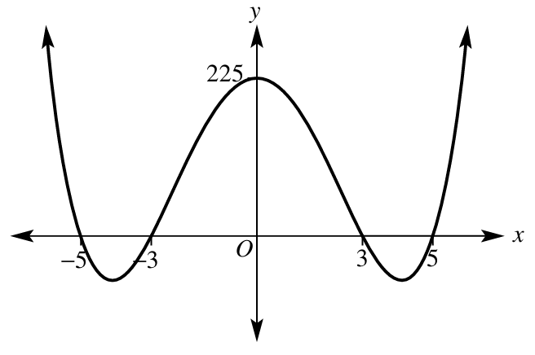
$P\left(x\right)=\left(x-2\right)\left(x-1\right)\left(x+1\right)\left(x+4\right)$
  - $P\left(x\right)=x^{4}-34x^{2}+225$

$P\left(x\right)=(x-5)(x-3)(x+3)(x+5)$

- Factorise $x^{4}-x^{3}-5x^{2}+12$.

$${\left(x-2\right)}^{2}\left(x^{2}+3x+3\right)$$
- A ladder of length 10 metres is leaning against a wall so that it is just touching a cube of edge length one metre.
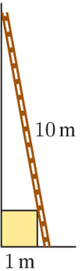
  - Let $x+1$ be the height up the wall that the ladder reaches and $y+1$ be the distance along the ground. Show that this scenario can be modelled using
$$x^{4}+2x^{3}-98x^{2}+2x+1=0$$
Hint: Use Pythagoras and similar triangles.

Using Pythagoras’ theorem:
$${\left(x+1\right)}^{2}+{\left(1+y\right)}^{2}={10}^{2}$$
Using similar triangles, $\frac{y}{1}$ $=$ $\frac{1}{x}$
$$∴y=\frac{1}{x}$$
$${\left(x+1\right)}^{2}+{\left(1+\frac{1}{x}\right)}^{2}={10}^{2}$$
Expand, multiply every term by $x^{2}$, then rearrange.
$$x^{4}+2x^{3}-98x^{2}+2x+1=0$$

  - Use an online calculator to find the height up the wall the ladder reaches to 2 decimal places.

$$x≈0.11 m or 8.94 m$$
So, height up the wall is 1.11 m or 9.94 m

